Jenkins Declarative pipeline Script

Pre-requisites
Step 1 — Launch an Ubuntu(22.04) T2 Large Instance
Install java:
sudo apt update
sudo apt install fontconfig openjdk-17-jre
java -version
openjdk version "17.0.8" 2023-07-18
OpenJDK Runtime Environment (build 17.0.8+7-Debian-1deb12u1)
OpenJDK 64-Bit Server VM (build 17.0.8+7-Debian-1deb12u1, mixed mode, sharing)

Install Jenkins:
sudo wget -O /usr/share/keyrings/jenkins-keyring.asc \
https://pkg.jenkins.io/debian-stable/jenkins.io-2023.key
echo deb [signed-by=/usr/share/keyrings/jenkins-keyring.asc] \
https://pkg.jenkins.io/debian-stable binary/ | sudo tee \
/etc/apt/sources.list.d/jenkins.list > /dev/null
sudo apt-get update
sudo apt-get install jenkins
sudo systemctl start jenkins
sudo systemctl enable jenkins
sudo systemctl status jenkins

Once Jenkins is installed, you will need to go to your AWS EC2 Security Group and open Inbound Port 8080, since Jenkins works on Port 8080.
Now, grab your Public IP Address
<EC2 Public IP Address:8080>
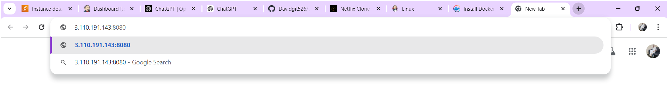
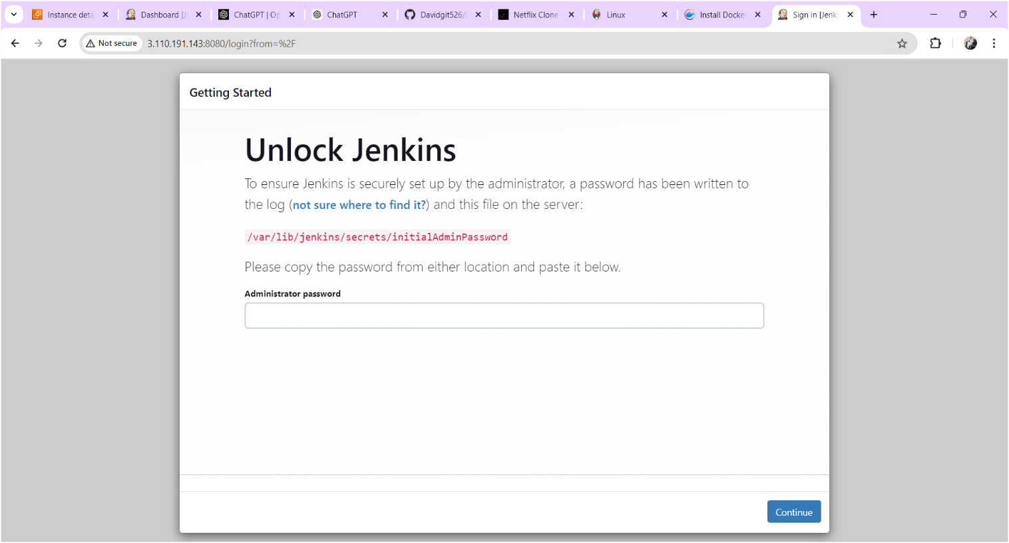

Copy the text which is mentioned in yellow colour box above and paste it using command “cat /var/lib/jenkins/secrets/initialAdminPassword” on your terminal after you will get below output.
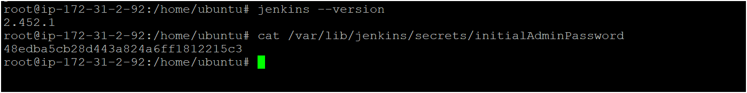
Copy the password for login to jenkins as shown above image
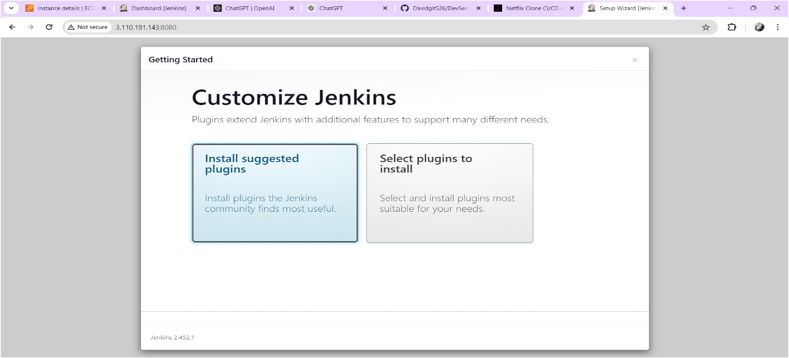
Click on Suggested plugins as shown above image after you will get output as shown below image
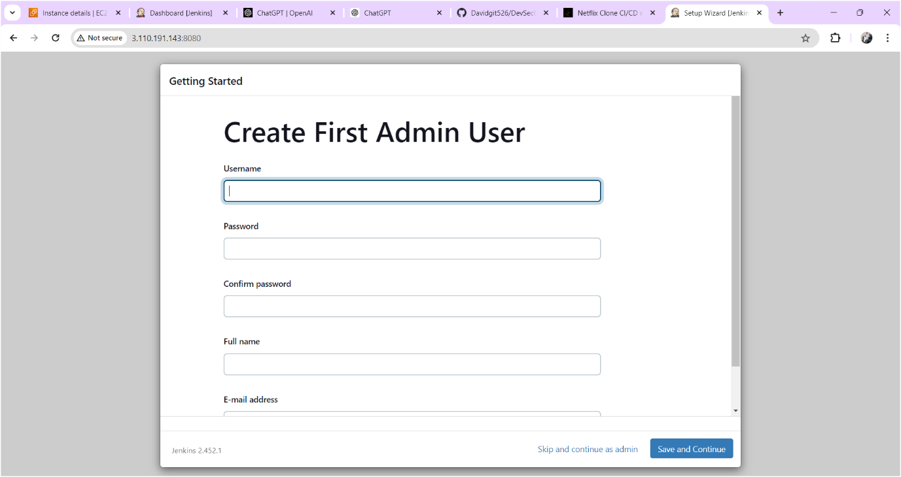
Click on skip and continue as admin
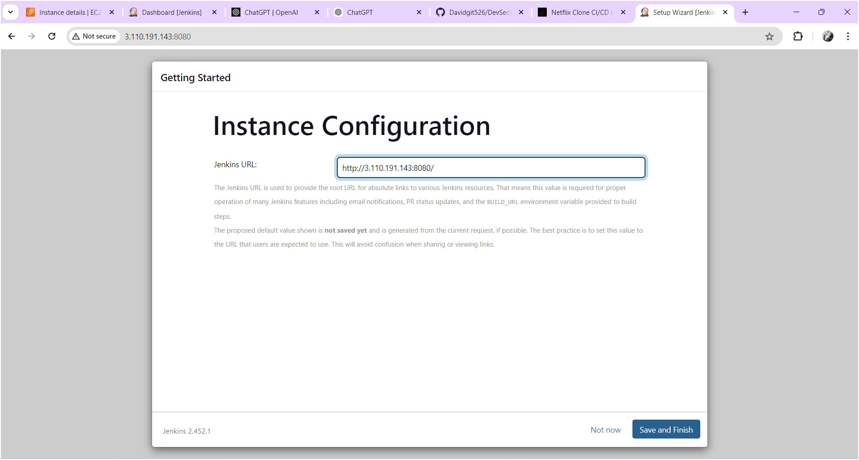
Click on save and finish
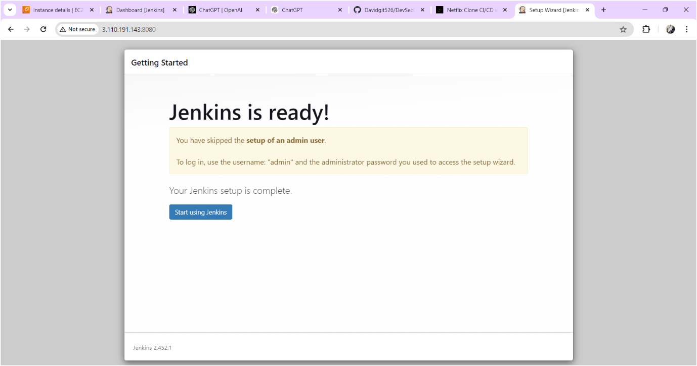
Click on start using jenkins
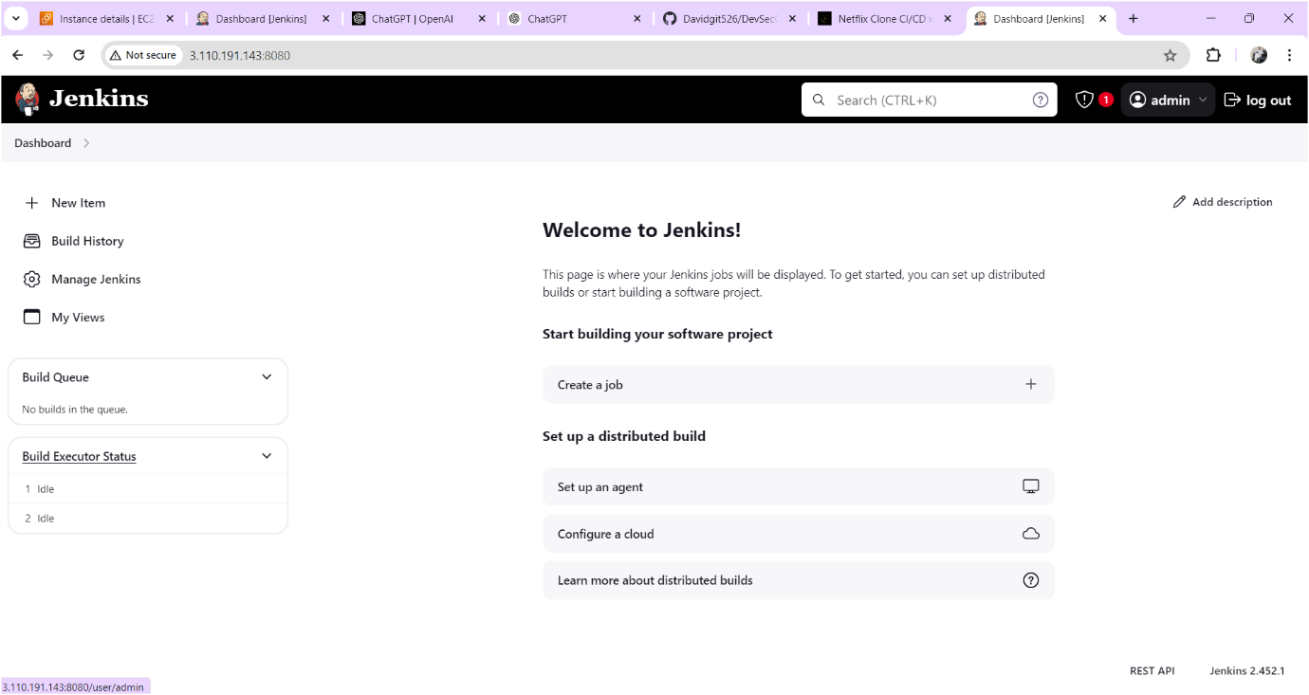

Now you should change the password for that
Click on adminclick on configure find password there you can change the password whatever you want. Output sown as below image
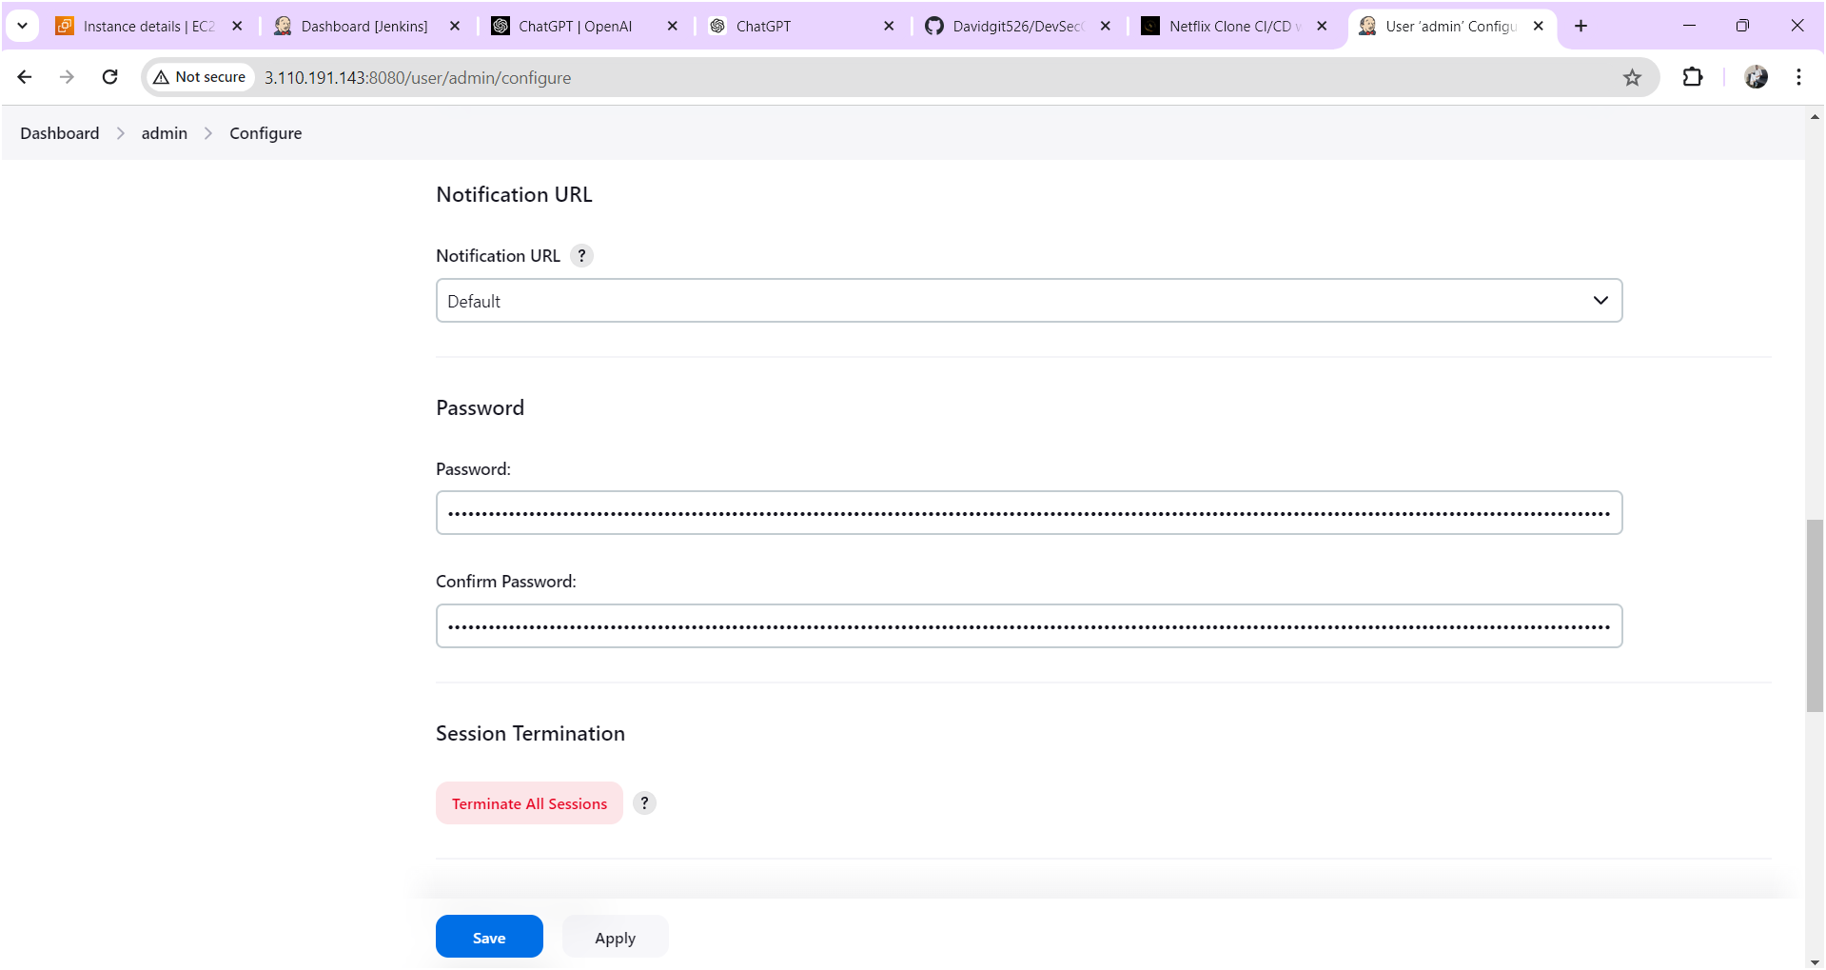
After changing the password click on apply and save after output will come as shown below image.
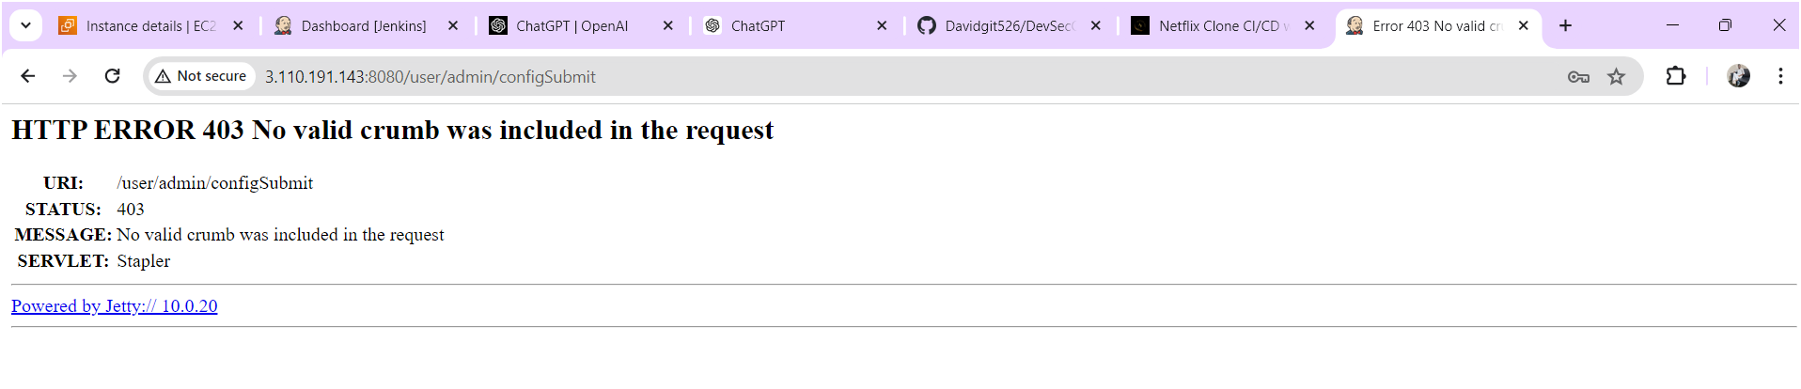
Now refresh the page after output will come as shown below image
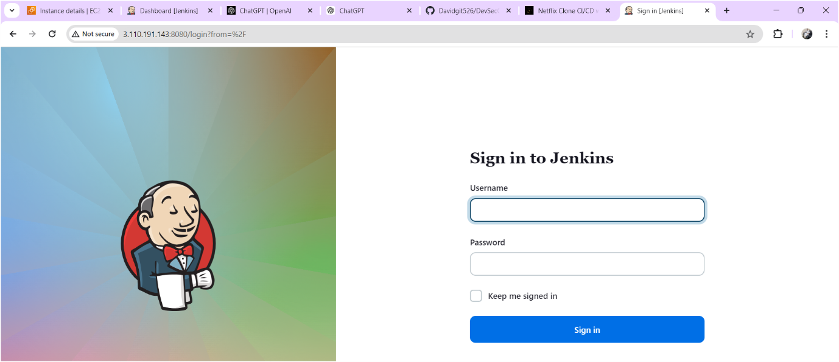
Login to the jenkins with your updated credentials after you will get jenkins home page as shown below.
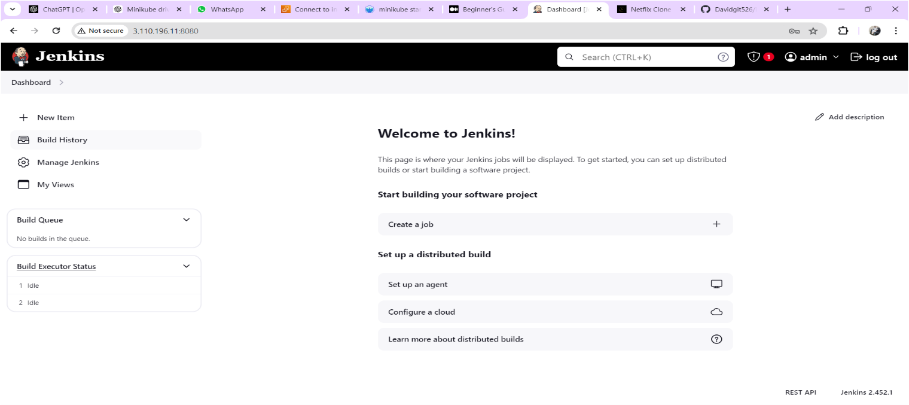
Install SonarQube:
Launch an Ubuntu(22.04) T2 medium Instance or you can install on jenkins server only (Note: If jenkins server running slowly you need to create another instance and install sonarqube.)
Set up Docker on the EC2 instance:
sudo apt-get update
sudo apt-get install docker.io -y
sudo usermod -aG docker $USER # Replace with your system's username, e.g., 'ubuntu'
newgrp docker
sudo chmod 777 /var/run/docker.sock

docker run -d --name sonar -p 9000:9000 sonarqube:lts-community

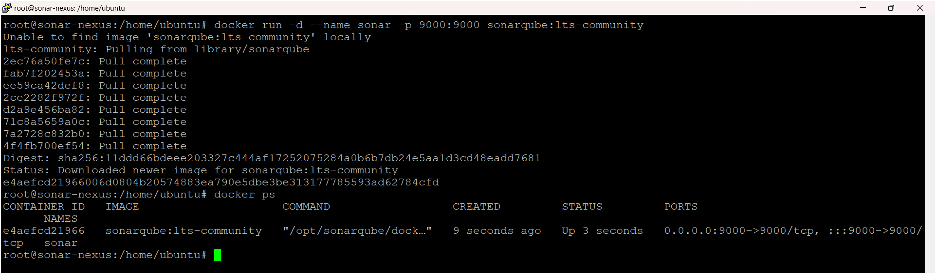
To access:
Need to open port number 9000 in security groups

publicIP:9000 (by default username & password is admin)

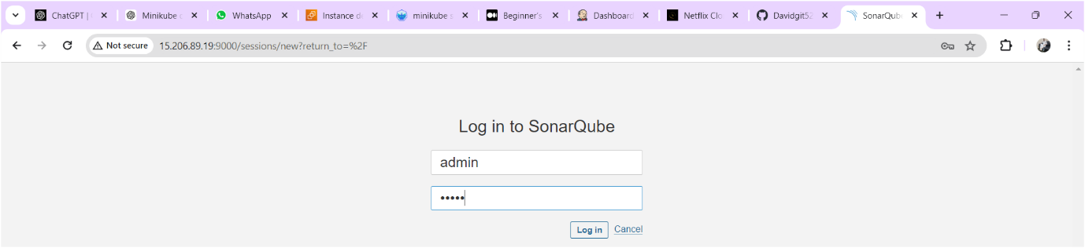

After login you need to change the password as shown below image
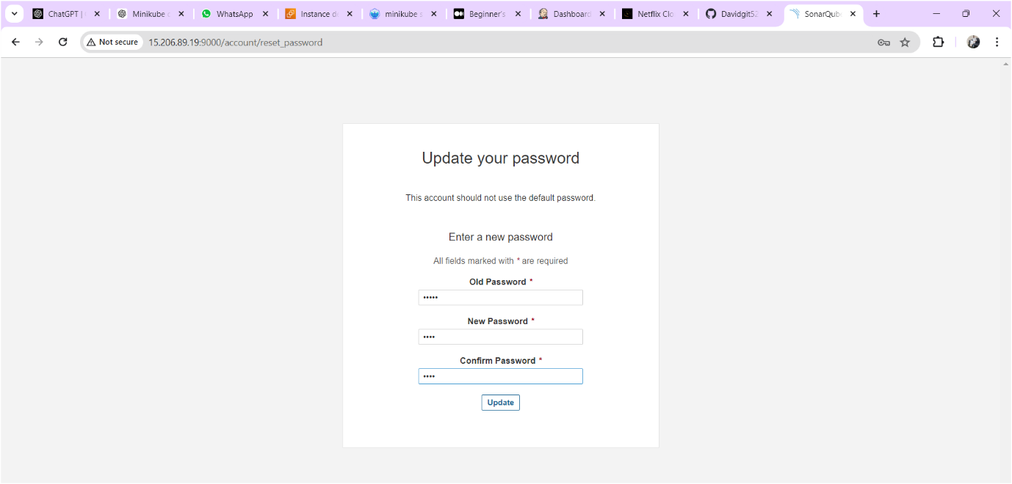

Sonarqube home page is as shown below
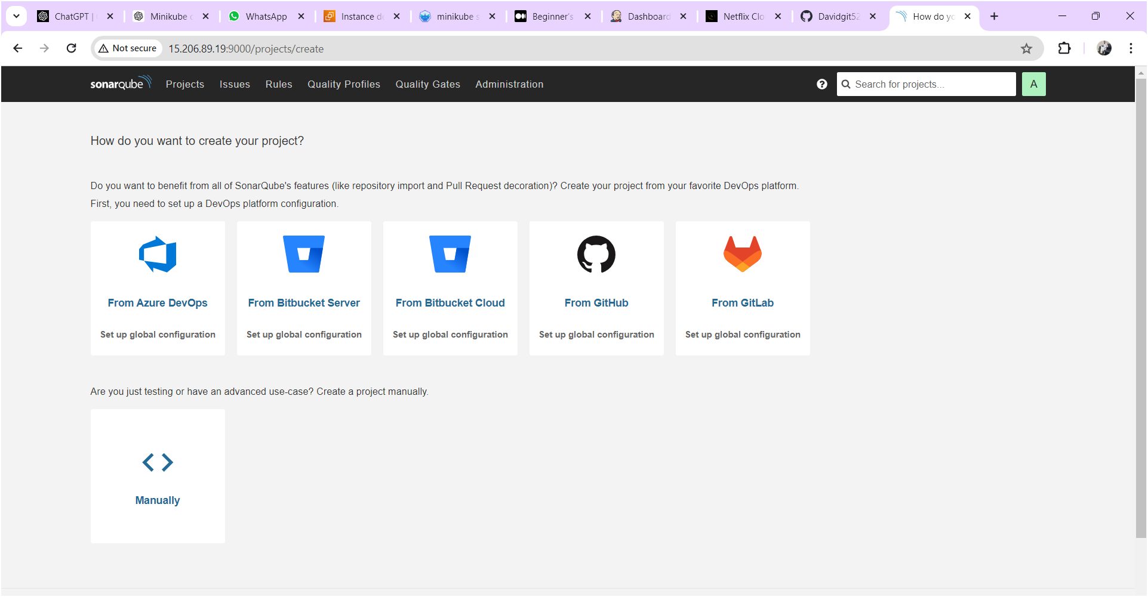

Configure Sonar Server in Manage Jenkins
Goto your Sonarqube Server. Click on Administration → Security → Users → Click on Tokens and Update Token → Give it a name → and click on Generate Token
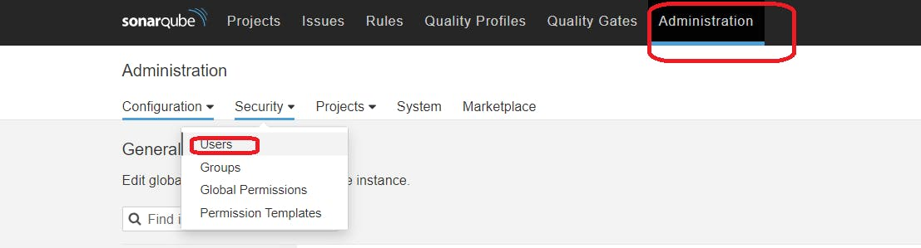
click on update Token
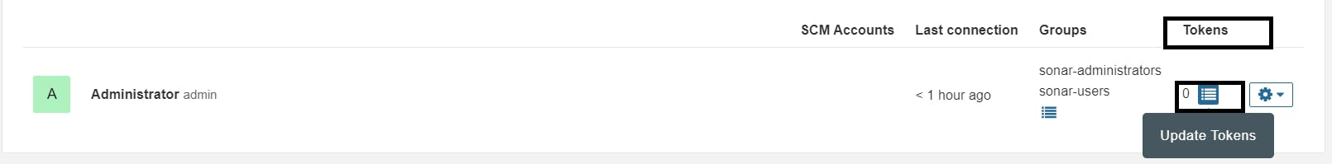
Give name for token and click on generate then token will generate and keep it save some other place for future use.
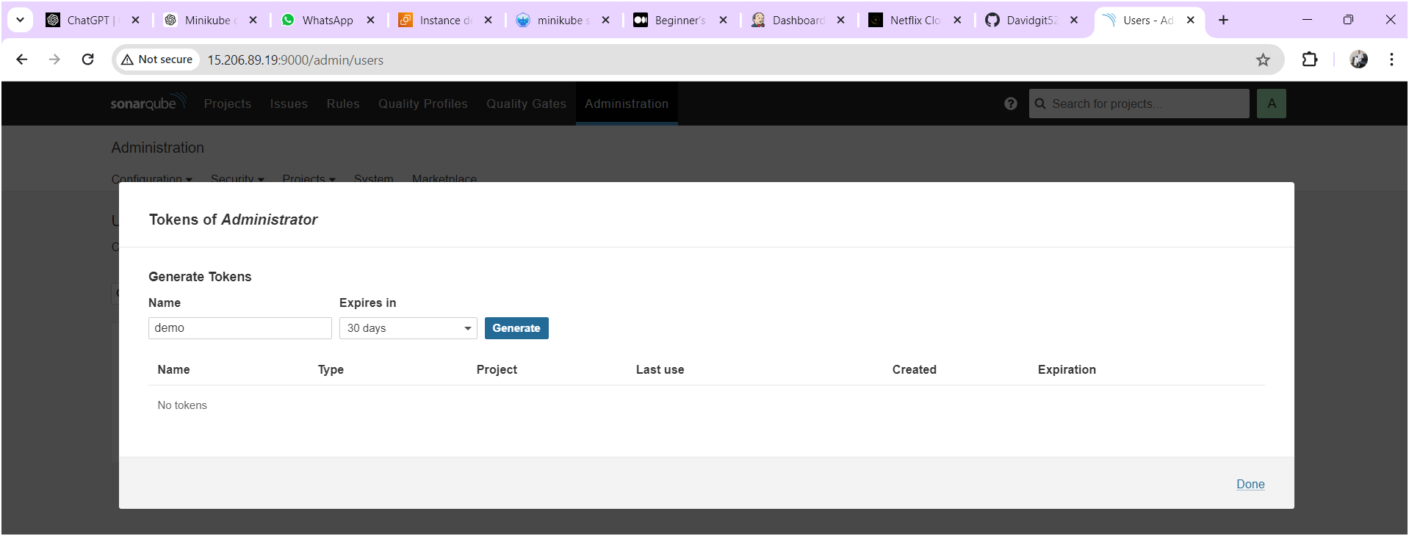
Copy the token save it at somewhere
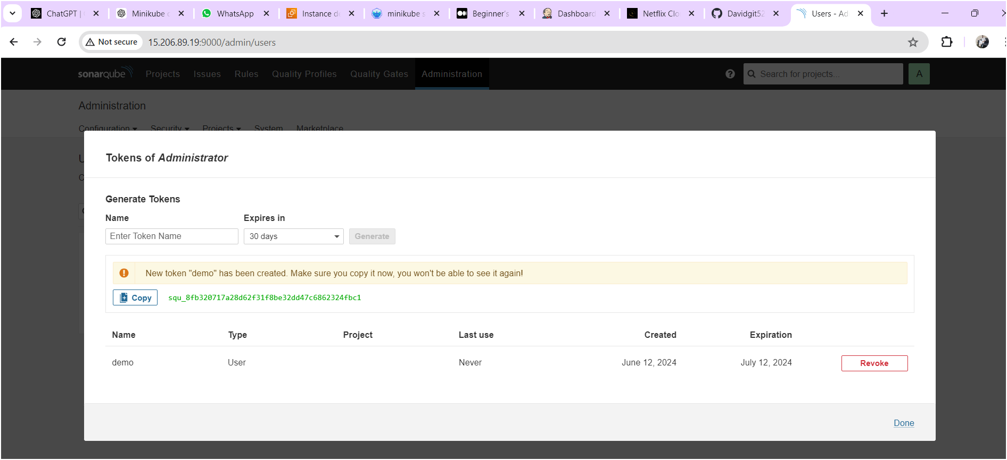

Goto Jenkins Dashboard → Manage Jenkins → Credentials → Add Secret Text. It should look like this.
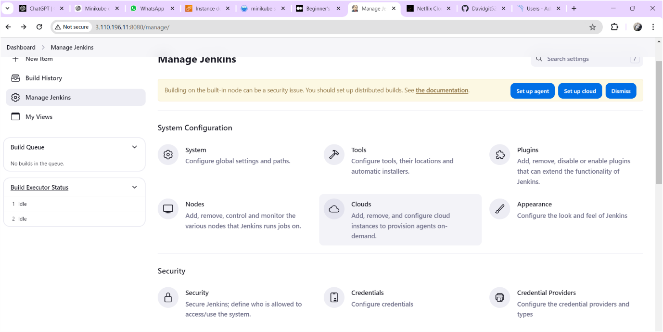
Click on “system” as shown below image
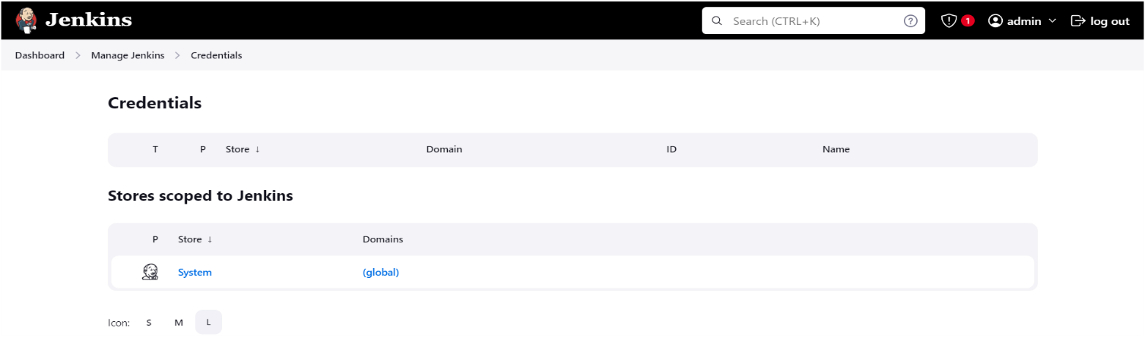

Click on “Global Credentials” as shown below image
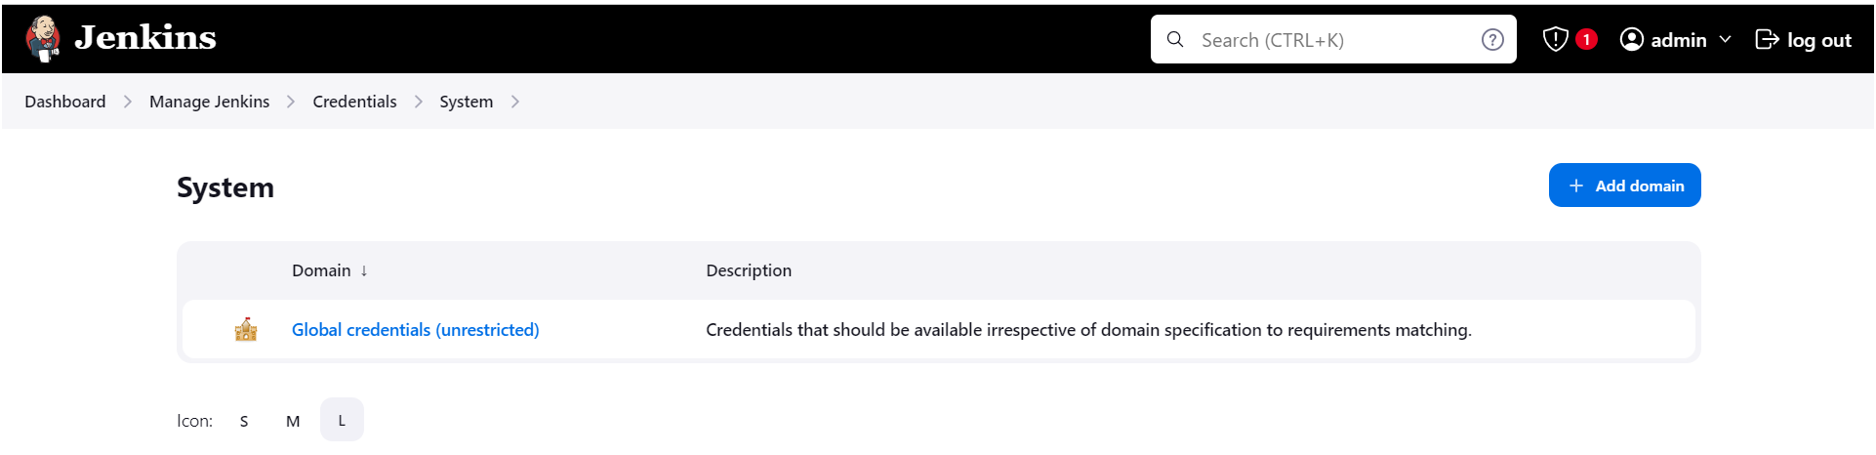
Here paste the token and give id and description as “sonar-token like below image.
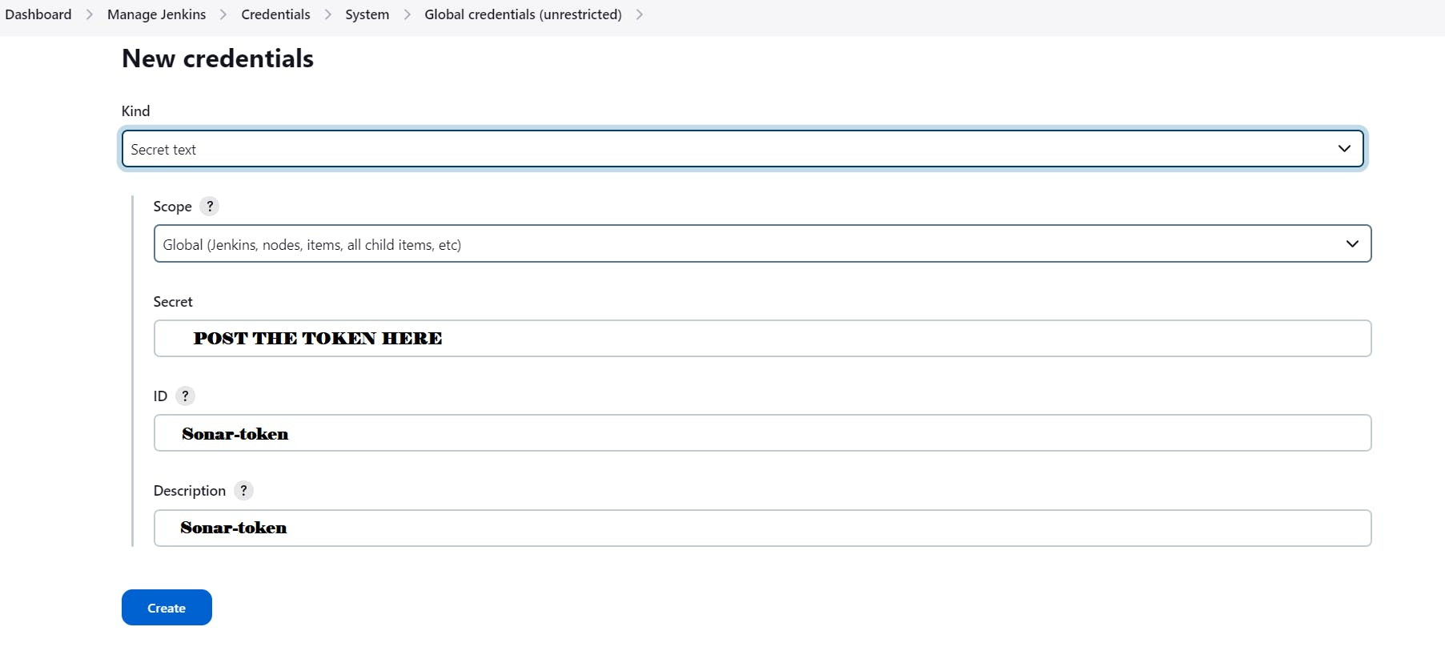
You will this page once you click on create
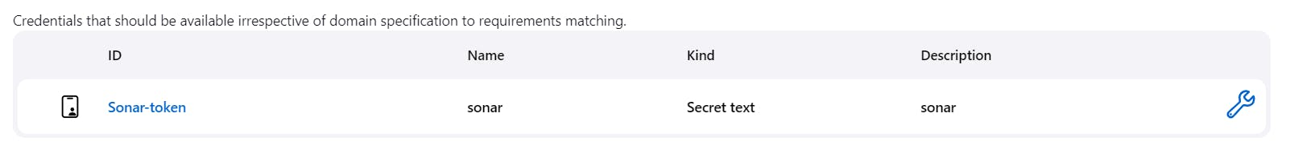
Now, go to Dashboard → Manage Jenkins → System and Add like the below image.
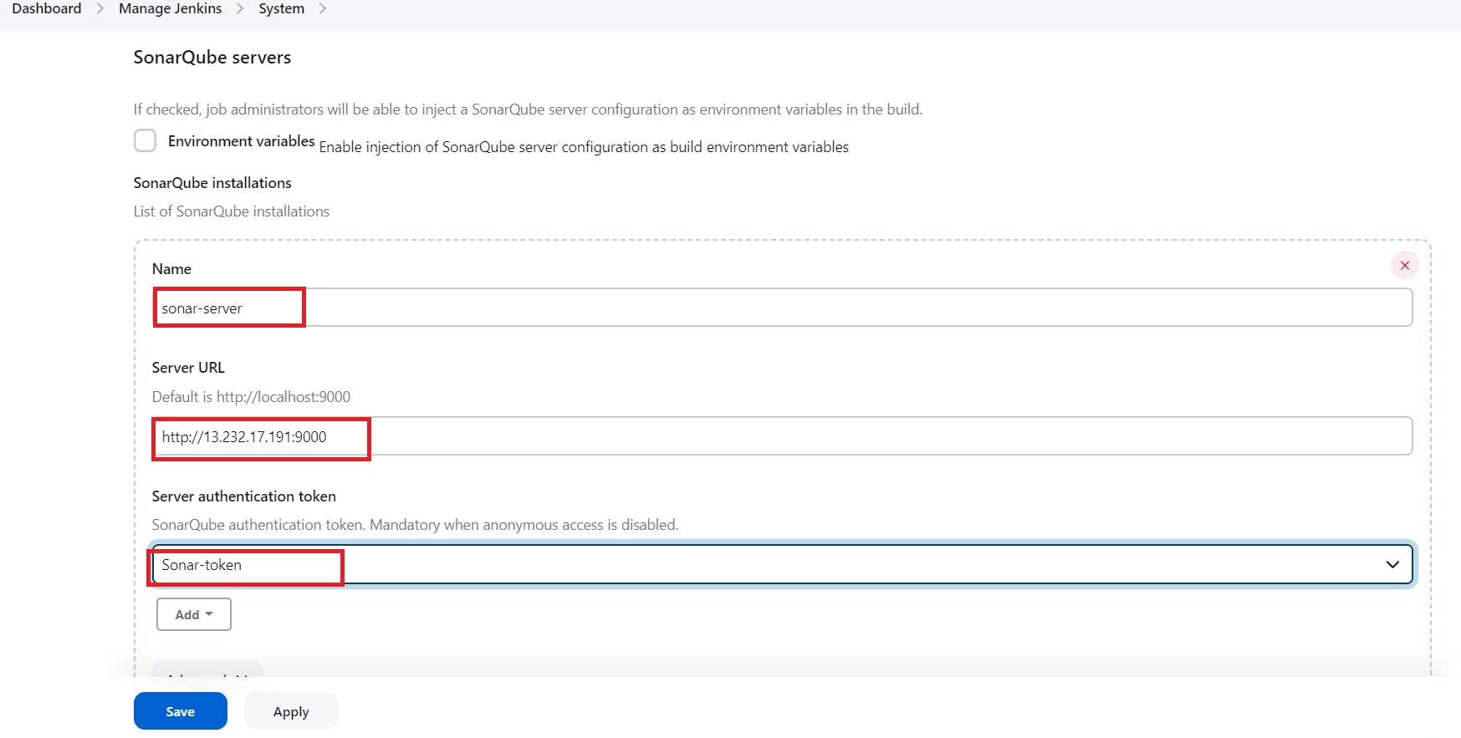
Click on Apply and Save
The Configure System option is used in Jenkins to configure different server
Global Tool Configuration is used to configure different tools that we install using Plugins
We will install a sonar scanner in the tools.
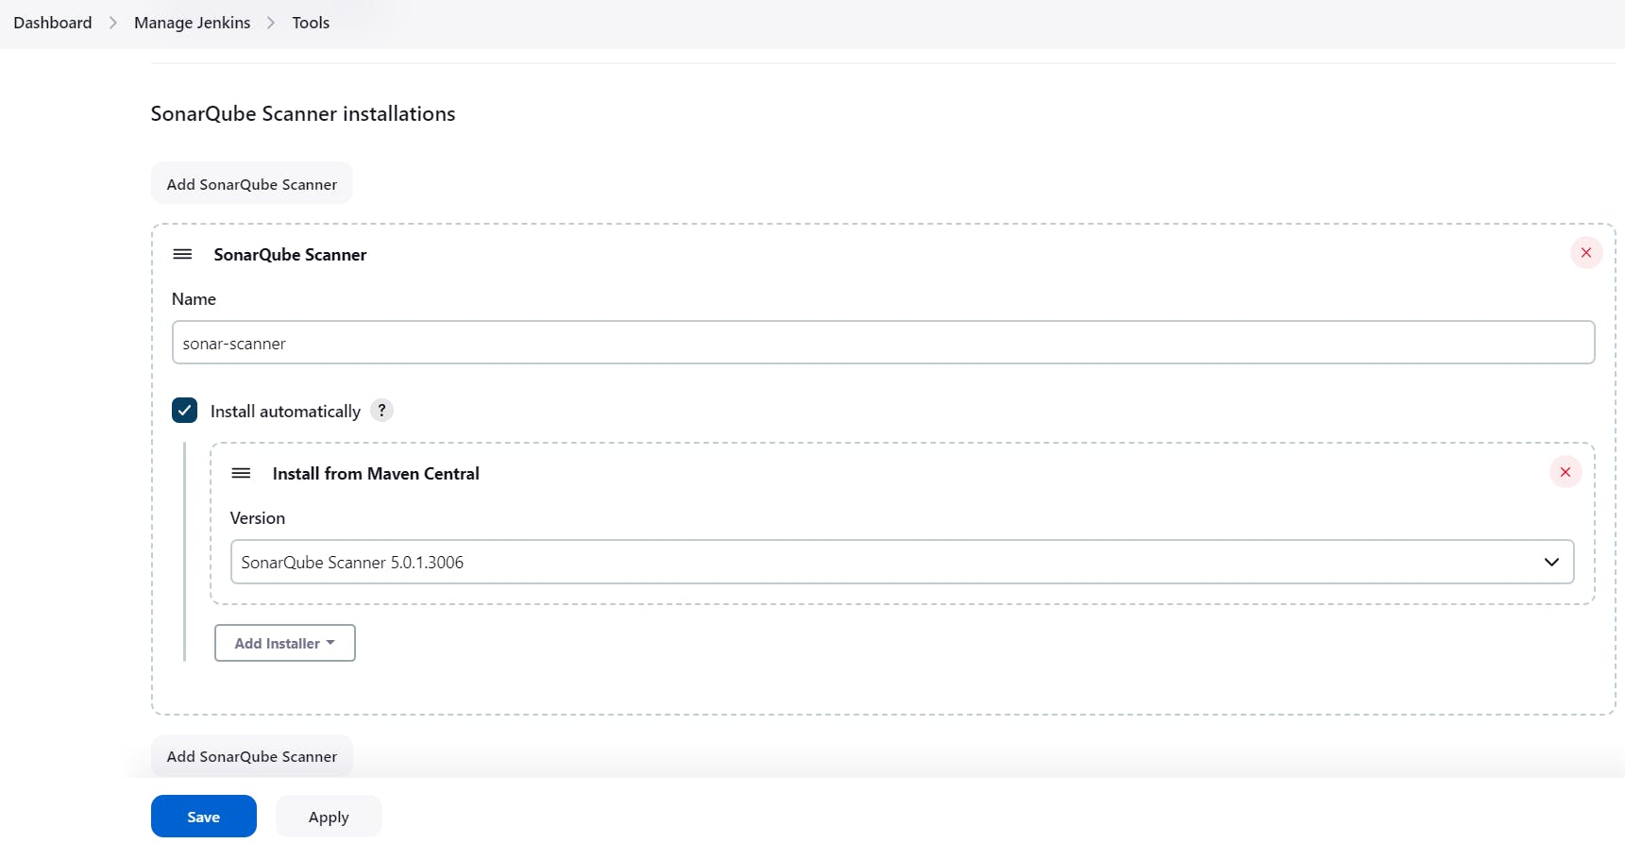
Next create a project in sonarqube server go to projectsmanually as shown below image.
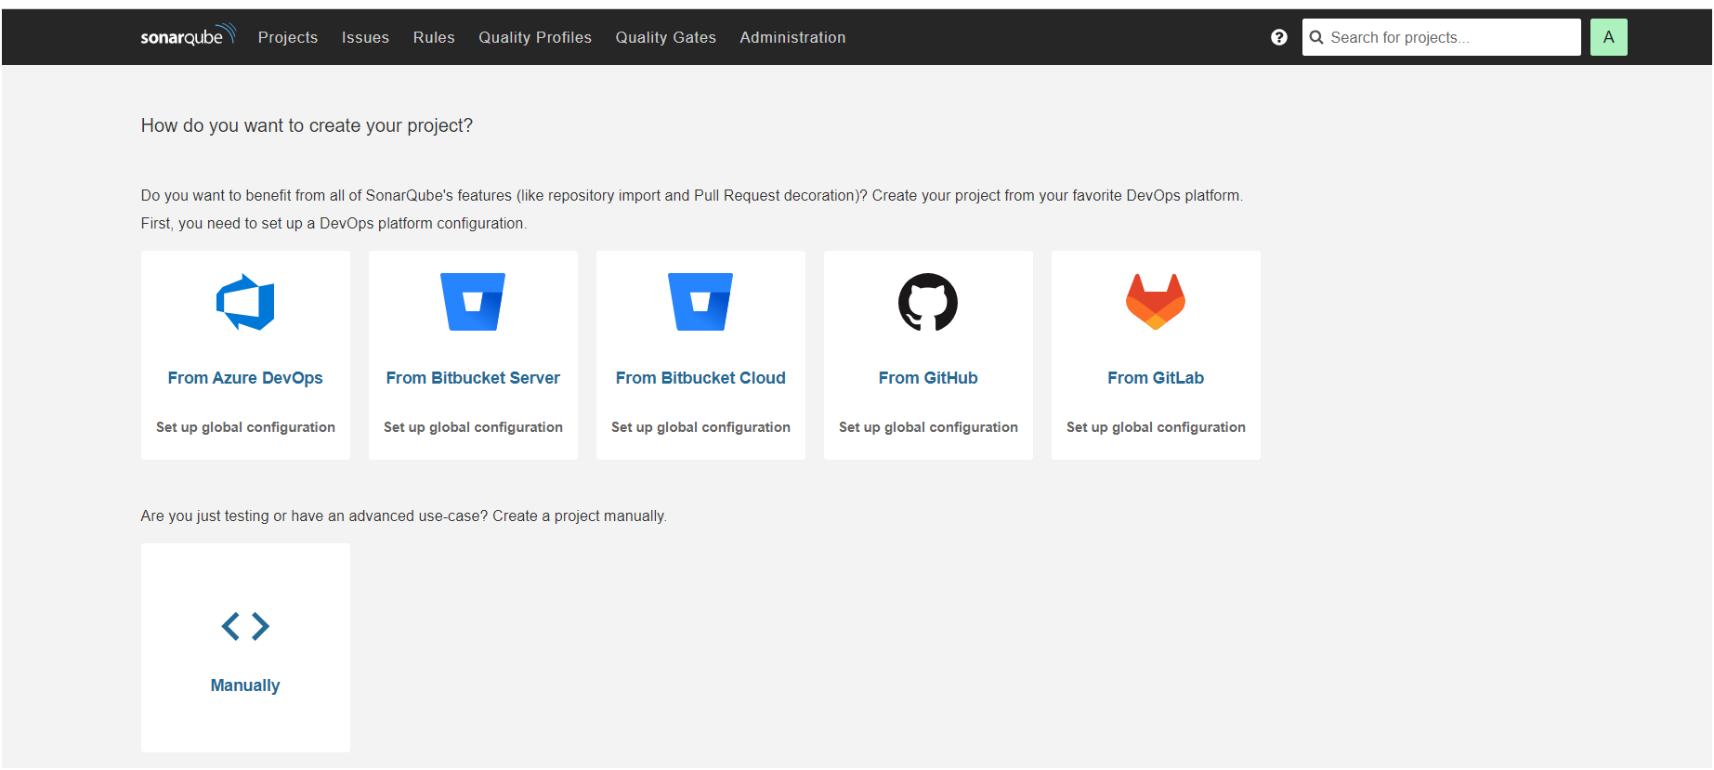
After clicking on “manually” you will get as shown below image

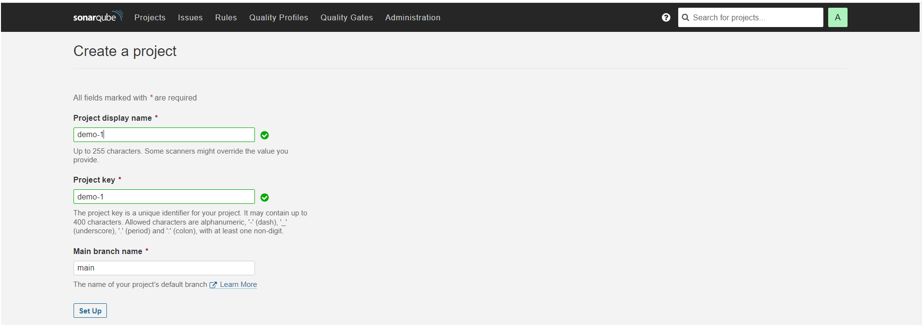
After click on “set up” you will get as shown below image.
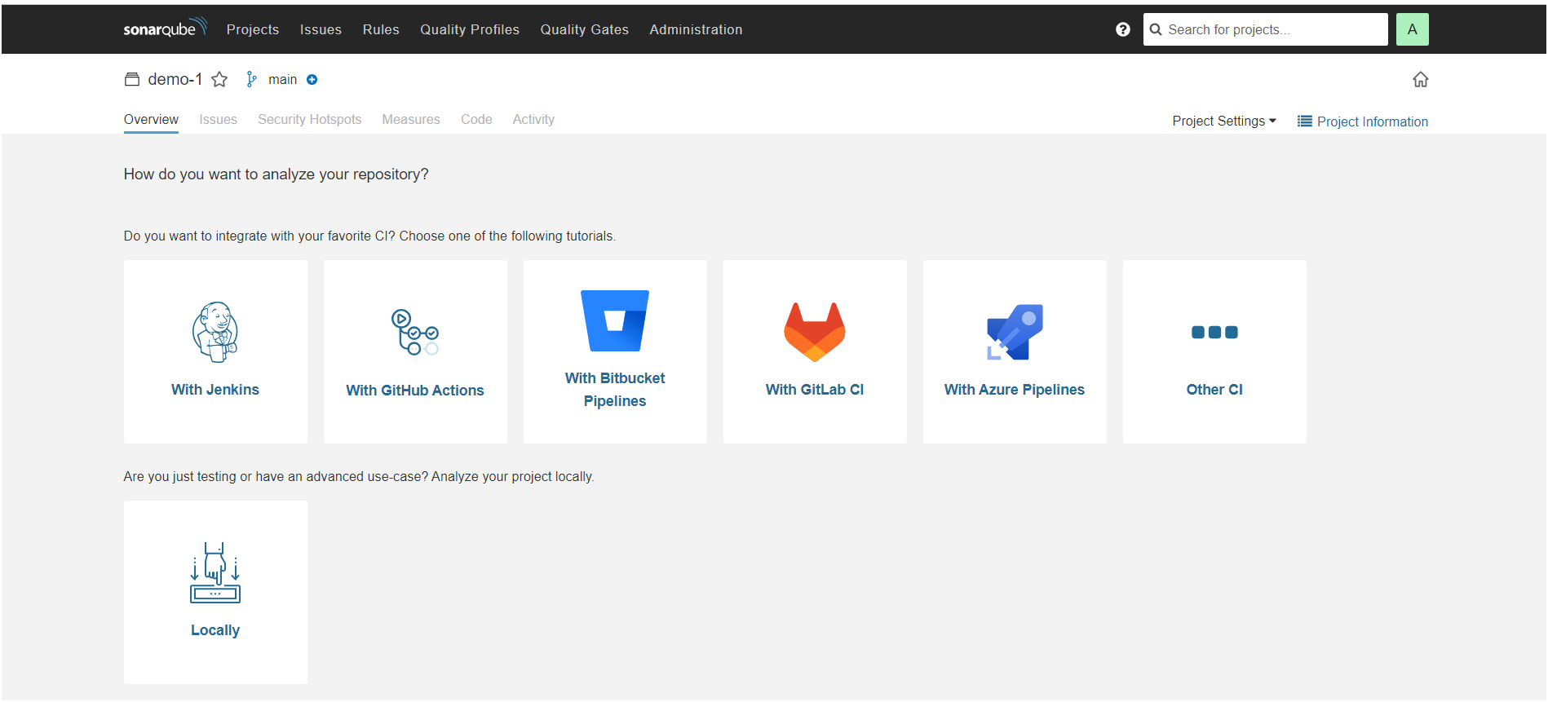
Once clicked on “locally” you will get next page as shown below after click on existing token and paste token here which we have generated a token after click on “continue”.
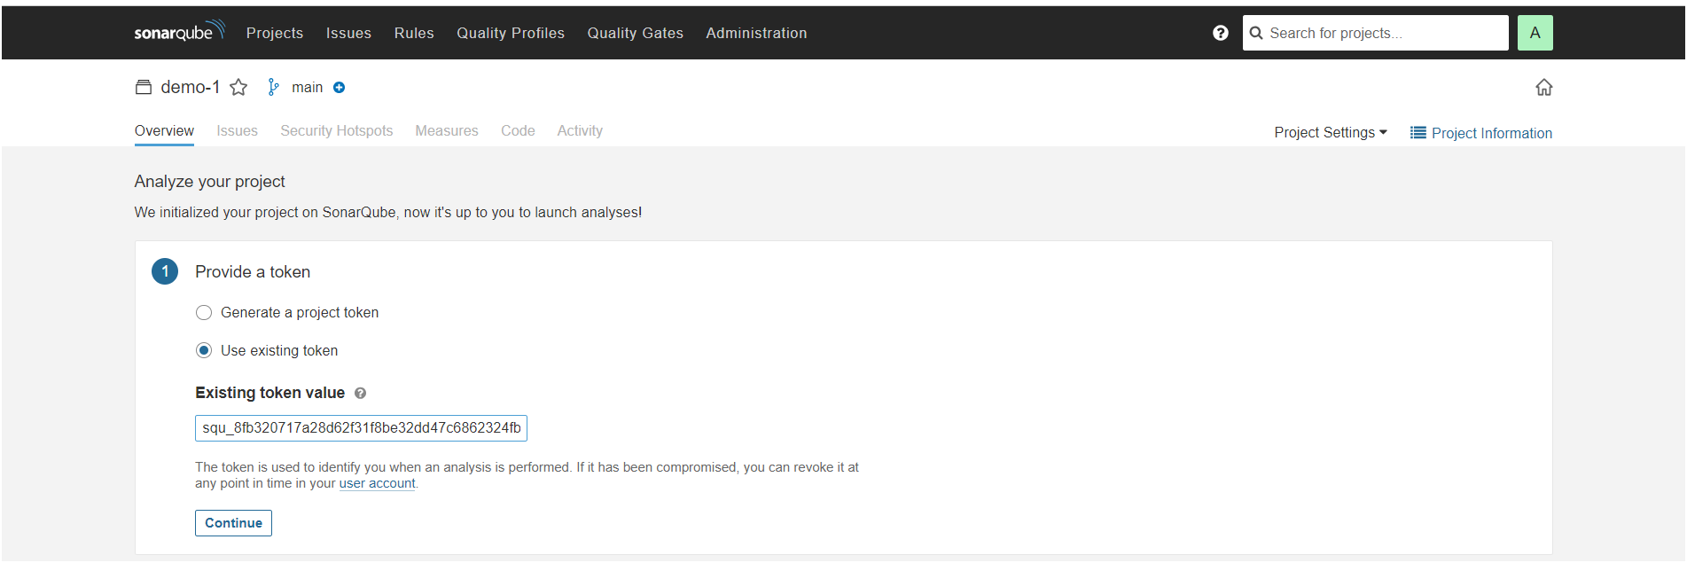
Next you will get page as shown below image
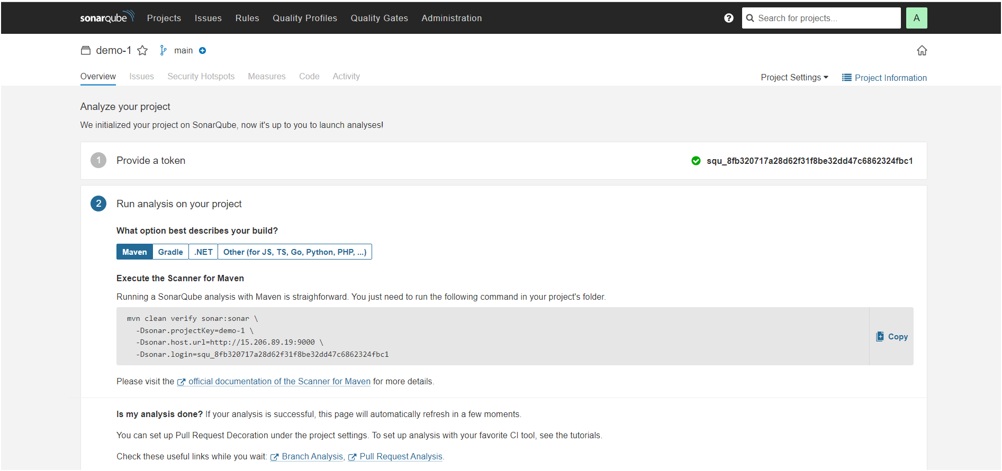

Install Plugins
- Eclipse Temurin Installer
- SonarQube Scanner
- Maven Integration
- Pipeline Maven Integration
- Deploy to Container
- Nexus Artifact Uploader
To install plugins, go to DashboardManage JenkinsAvailable Plugins
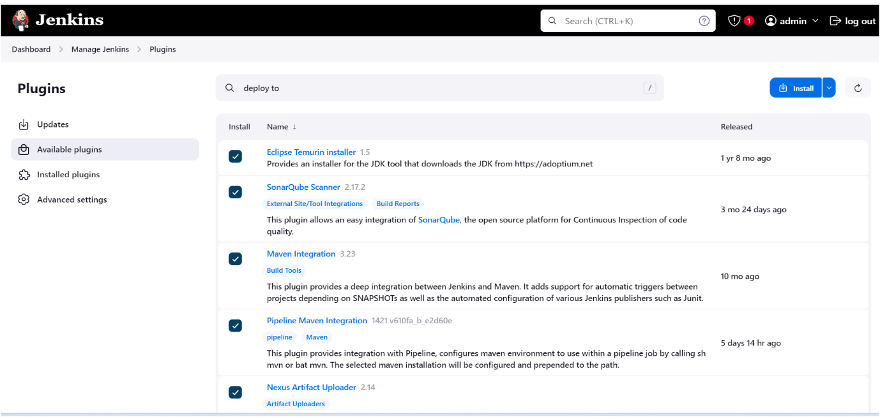
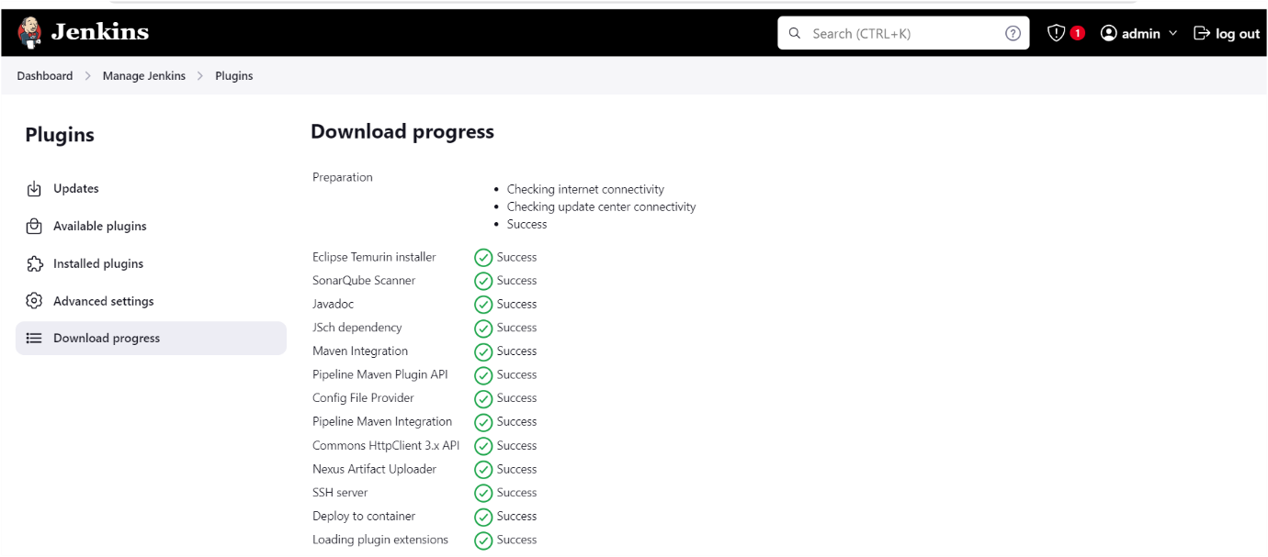

Configure jdk go to manage Jenkinstools as shown below images
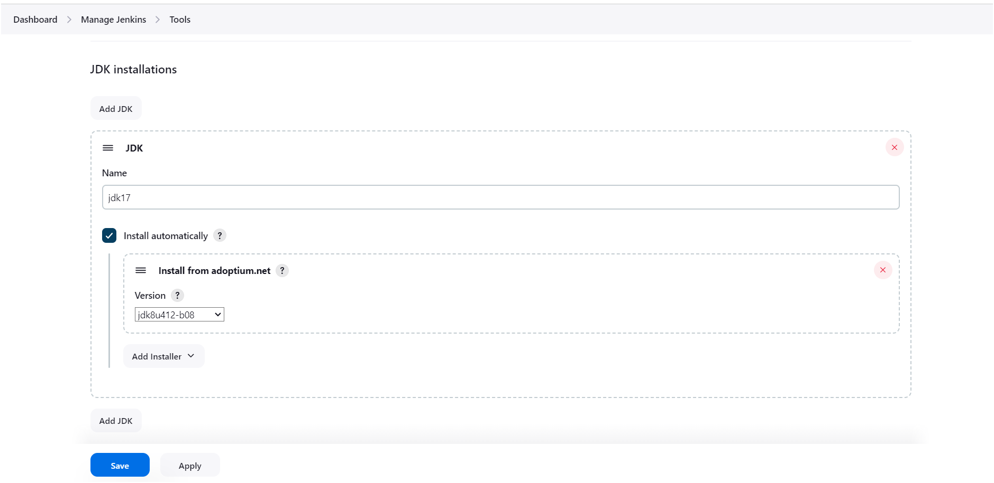
Click on apply and save️
Configure Sonarqube go to manage Jenkinstools as shown below image

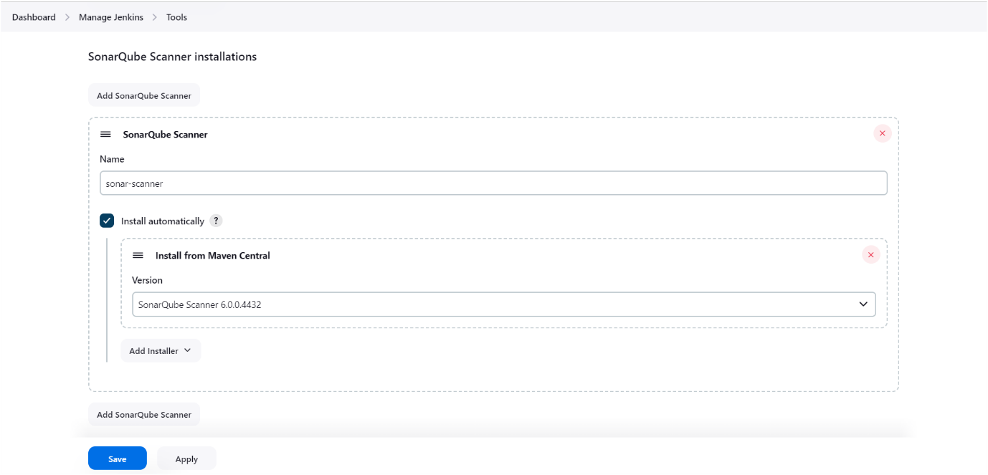
Click on apply and save️
Configure Sonarqube go to manage Jenkinssystems as shown below image, in server URL you need to provide your sonarqube server URL
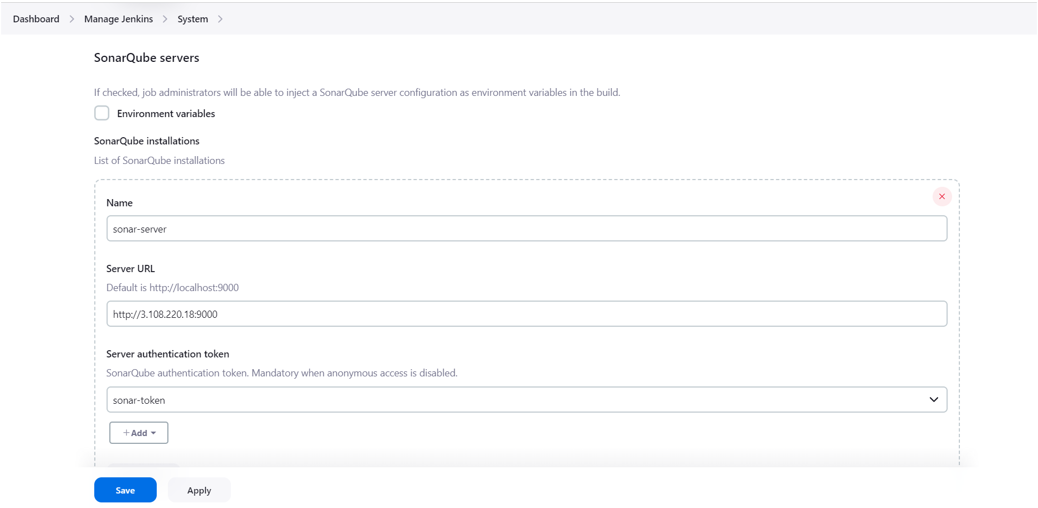
Click on apply and save️

Configure maven go to manage jenkinstools as shown below image
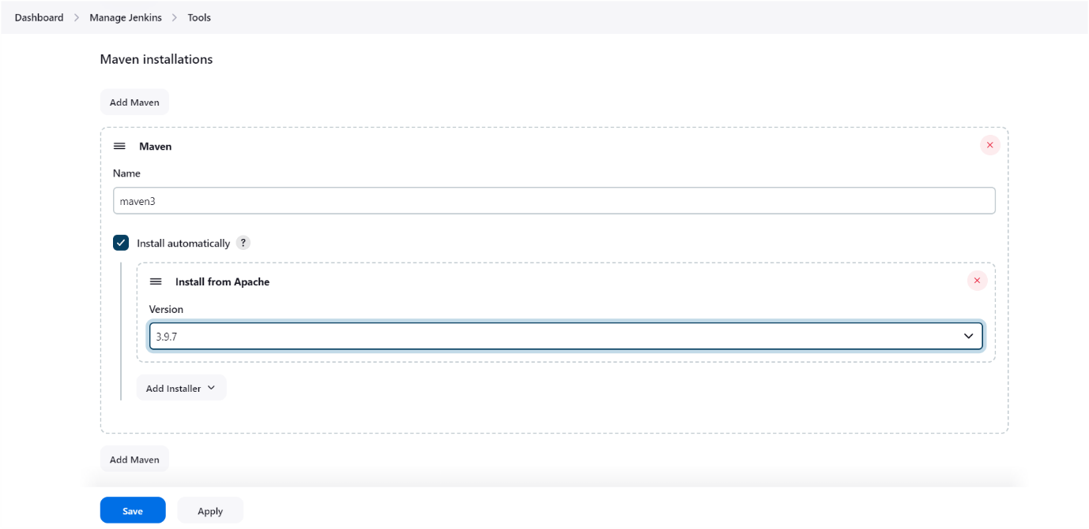
Click on apply and save️
Before Configure nexus you have to deploy nexus application inside the container as shown below
Install nexus server
docker run -d --name nexus -p 8081:8081 sonatype/nexus3
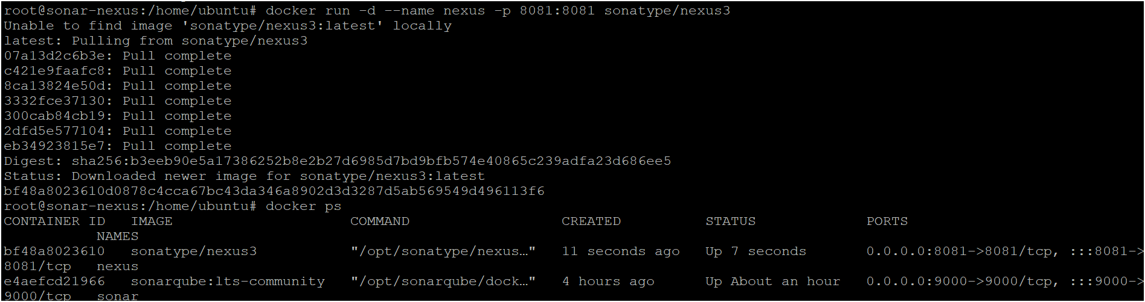
To access:
Need to open port number 8081 in security groups

publicIP:9000 by default username is admin and for password follow below steps
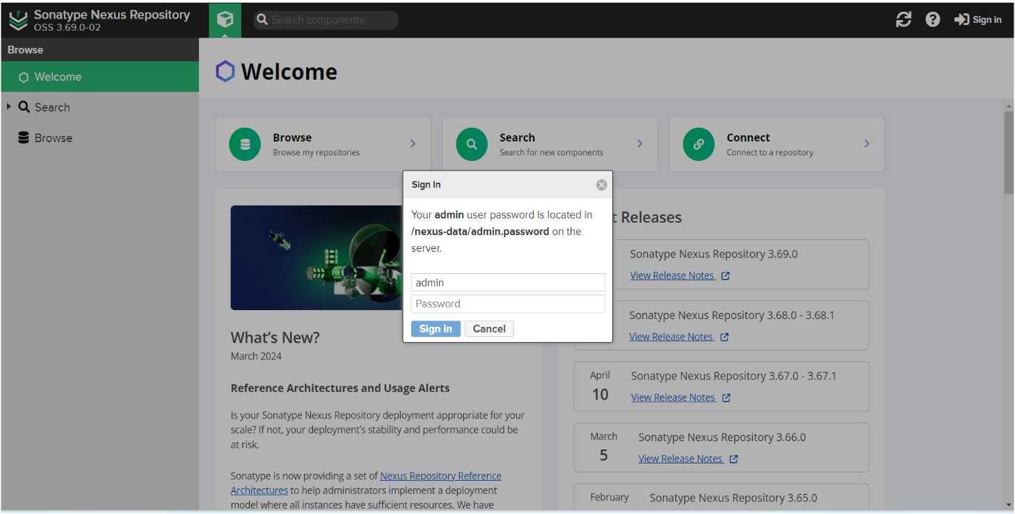
To get password execute follow commands as shown below
docker exec -it nexus cat /nexus-data/admin.password run that commands in your server where you have deployed nexus server as shown below
This is the password for nexus copy and login to the nexus server as shown below image
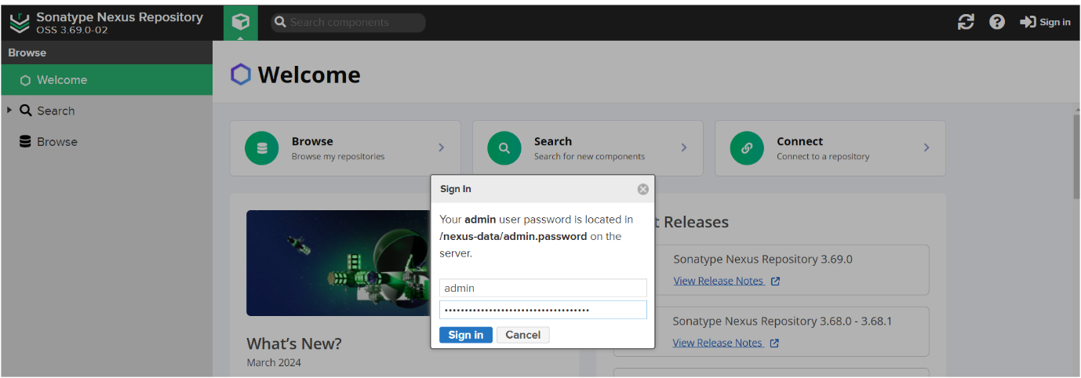

Nexus home page will appear as shown below
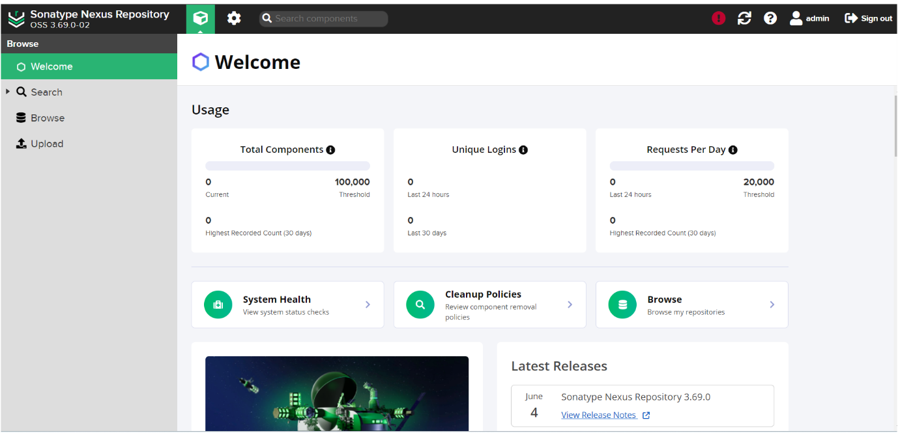
Configure or set up nexus in jenkins go to manage jenkinsgo to manged files as shown below image
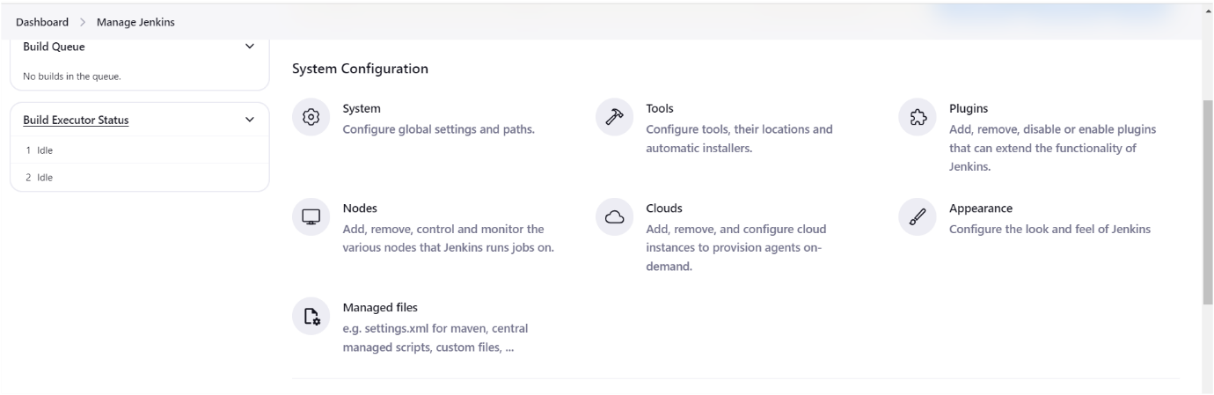
Click on Add a new configclick on Global Maven settings.xml as shown below image
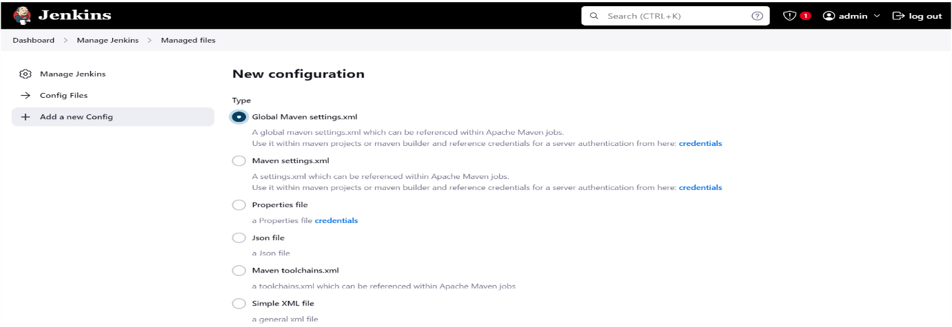
Next scroll down go to ID give name as “global-settings” as shown below image
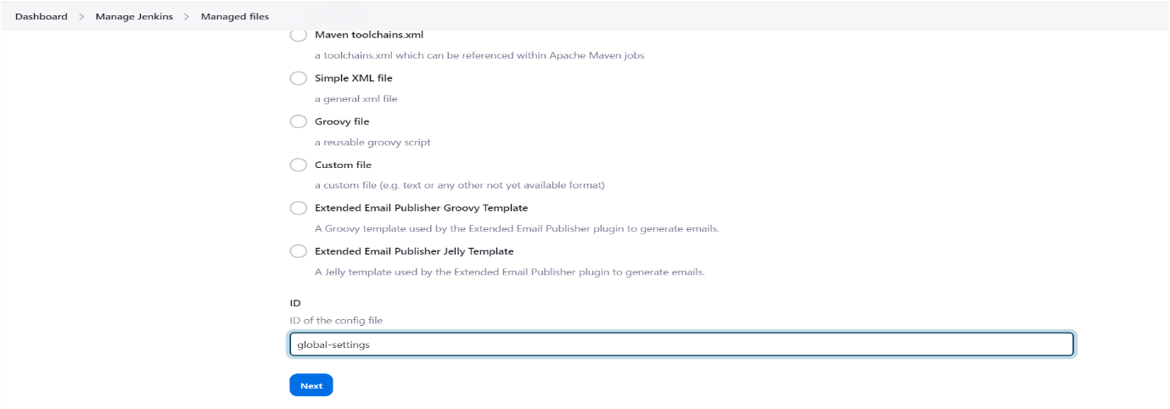
Click on next️
Next provide credentials of nexus server (give your nexus credentials) as shown below image
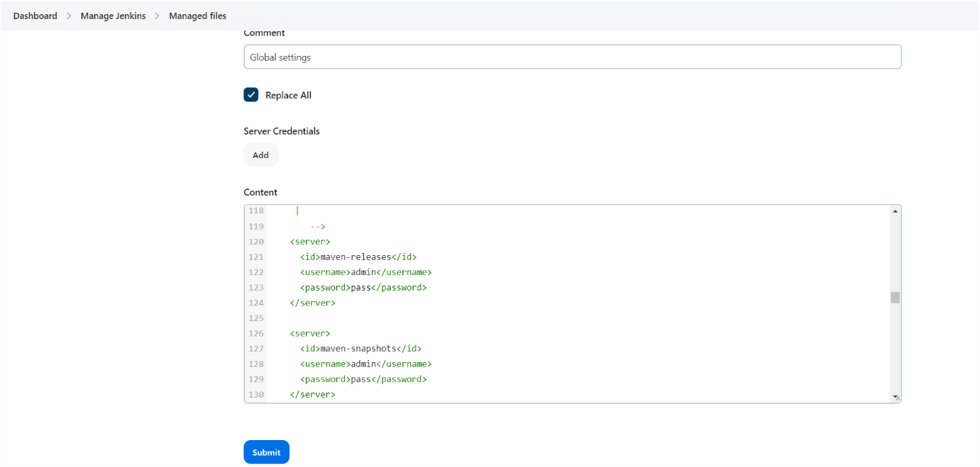
Click on submit️

Next need to update maven-snapshots and maven-releases URLs in your pom.xml file as shown below image
For getting maven-releases url follow below steps
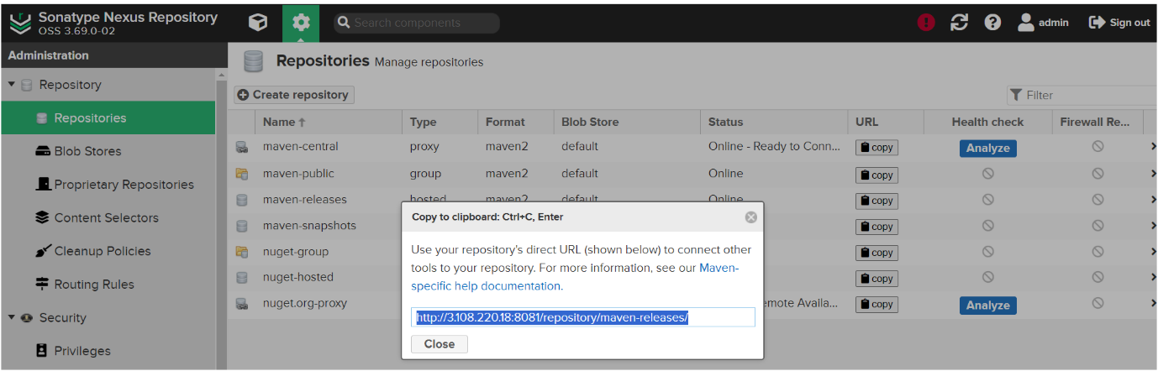
Update the above url in your pom.xml as shown below image
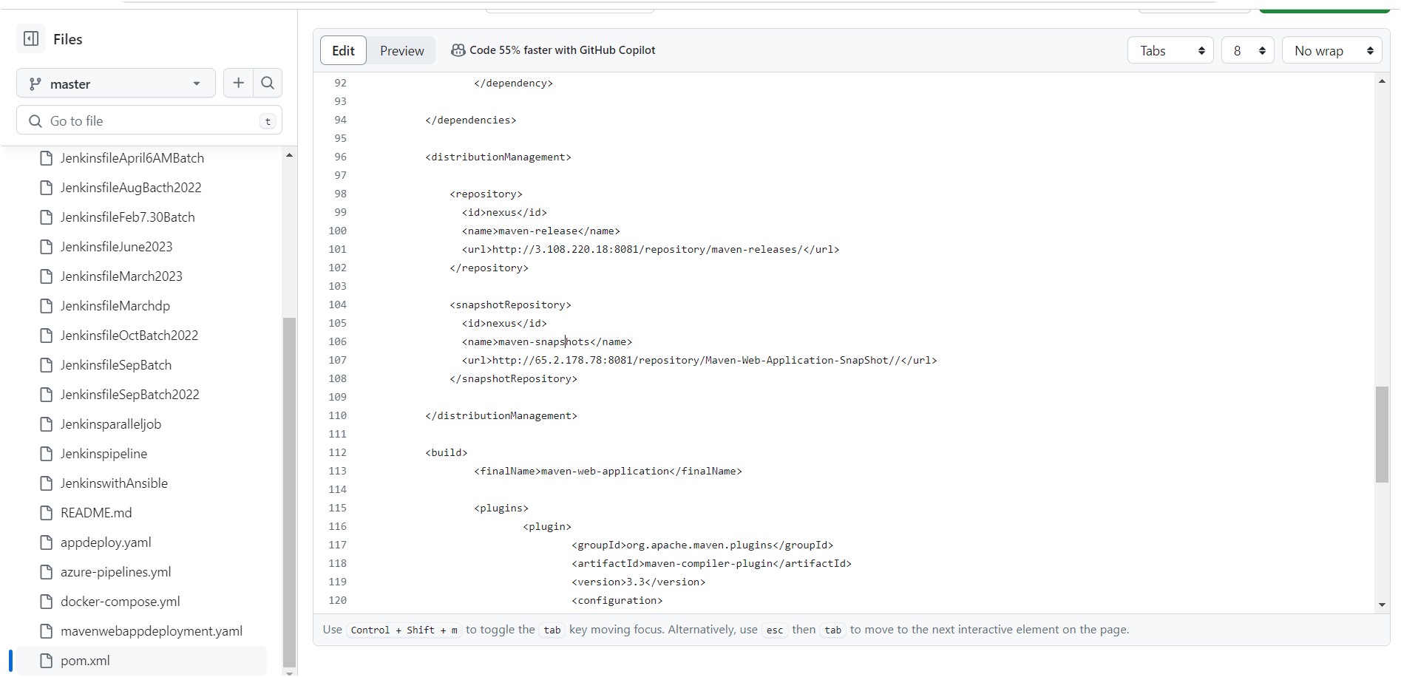
For getting maven-snapshots URL follow below steps
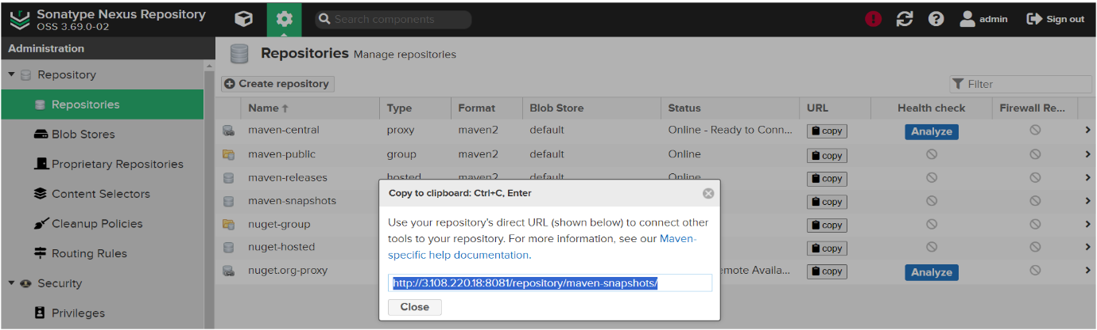
Update the above URL in your pom.xml as shown below image
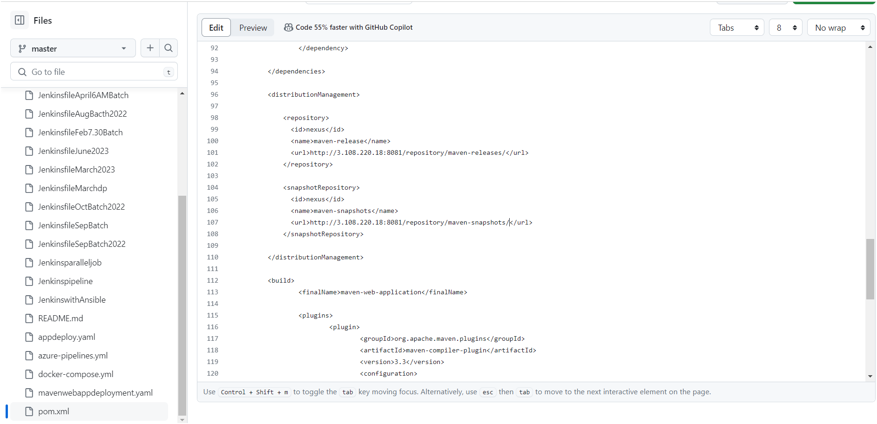
Next you need to commit the changes as shown below image at your GitHub repository
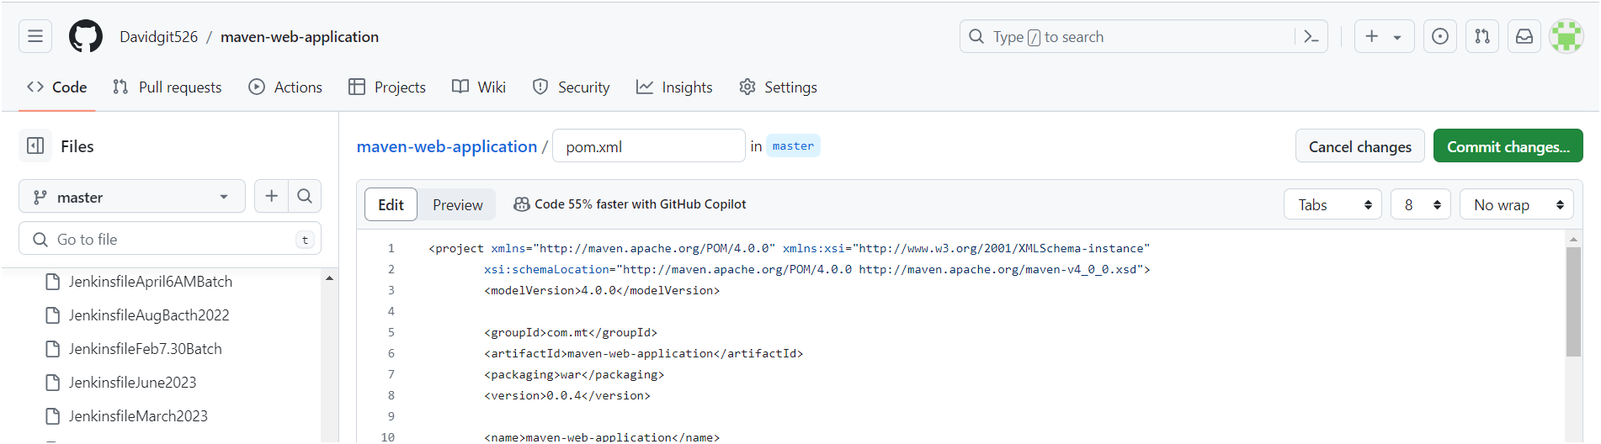
Install Tomcat on Ubuntu 24.04 LTS

Step #1: Install Java on Ubuntu 24.04 LTS
To install Tomcat, you should have Java installed. Tomcat relies on Java to function.
First update the package repository.
sudo apt update

Install Openjdk (Java).
sudo apt install openjdk-17-jdk

Step #2: Create a Tomcat User
For security reasons, it’s best not to run Tomcat as the root user. Let’s create a dedicated user and group.
sudo useradd -m -U -d /opt/tomcat -s /bin/false tomcat
This command creates a user named “tomcat” with a home directory at /opt/tomcat. The /bin/false shell prevents login access.

Step #3:Install Tomcat on Ubuntu 24.04 LTS
Now let’s install Tomcat. First navigate to the Tomcat official website and download the latest version of Tomcat 10. You can use wget for this purpose.
sudo wget https://www-eu.apache.org/dist/tomcat/tomcat-10/v10.1.24/bin/apache-tomcat-10.1.24.tar.gz -P /tmp
extract it to the /opt/tomcat directory.
sudo tar -xvf /tmp/apache-tomcat-10.1.24.tar.gz -C /opt/tomcat

Step #4:Update Permissions of Tomcat
Change ownership of the Tomcat directory to the tomcat user and group:
sudo chown -R tomcat:tomcat /opt/tomcat

Step #5: Configure Tomcat as a Service
A systemd unit file tells systemd how to manage a service. Create a file named tomcat.service under the /etc/systemd/system directory using a text editor.
navigate to the /etc/systemd/system.
cd /etc/systemd/system
Create a tomcat.service file using nano command.
sudo nano tomcat.service
add the following content into it.
[Unit]
Description=Tomcat Server
After=network.target

[Service]
Type=forking
User=tomcat
Group=tomcat
Environment="JAVA_HOME=/usr/lib/jvm/java-17-openjdk-amd64"
WorkingDirectory=/opt/tomcat/apache-tomcat-10.1.24
ExecStart=/opt/tomcat/apache-tomcat-10.1.24/bin/startup.sh

[Install]
WantedBy=multi-user.target
Save and close the file.
Adjust the JAVA_HOME environment variable path based on your OpenJDK installation location.

Step #6:Reload systemd and Start Tomcat
Reload the systemd daemon to apply the changes.
sudo systemctl daemon-reload
Start the Tomcat service.
sudo systemctl start tomcat
Enable Tomcat to start on boot.
sudo systemctl enable tomcat
Configure tomcat credentials in your tomcat server as shown below image
Follow the commands as shown below image
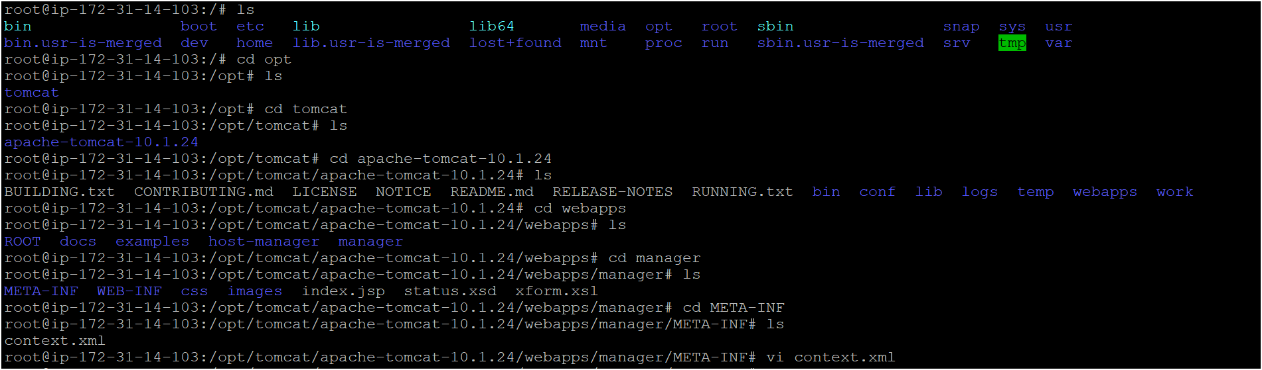
After it will open like the below image
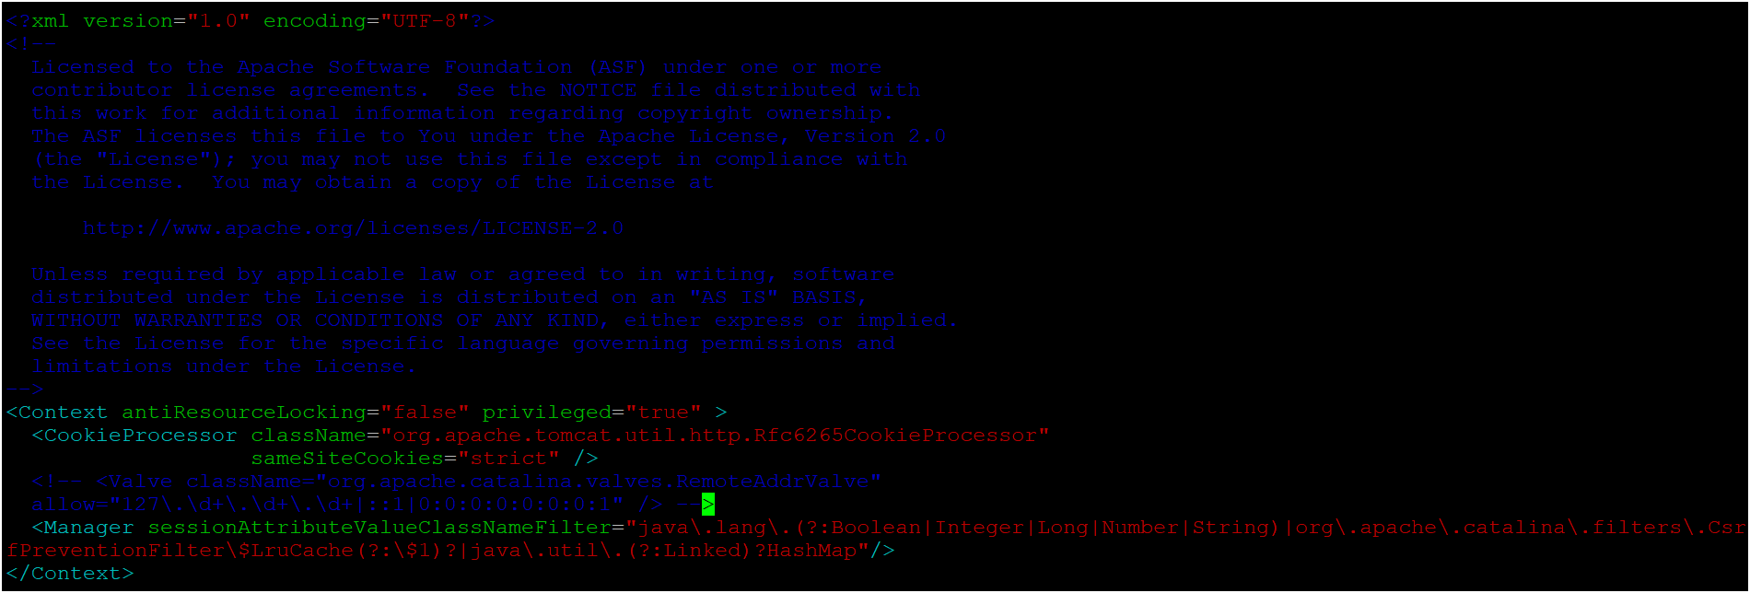
You need to edit this file as shown above image️
Next Configure credentials for tomcat server as shown below image
Follow the commands as shown below image
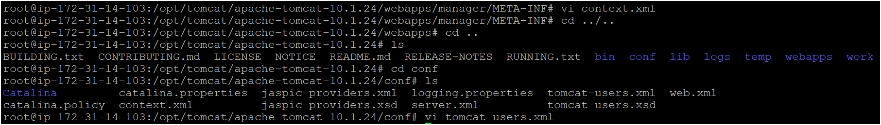
After it will open like the below image
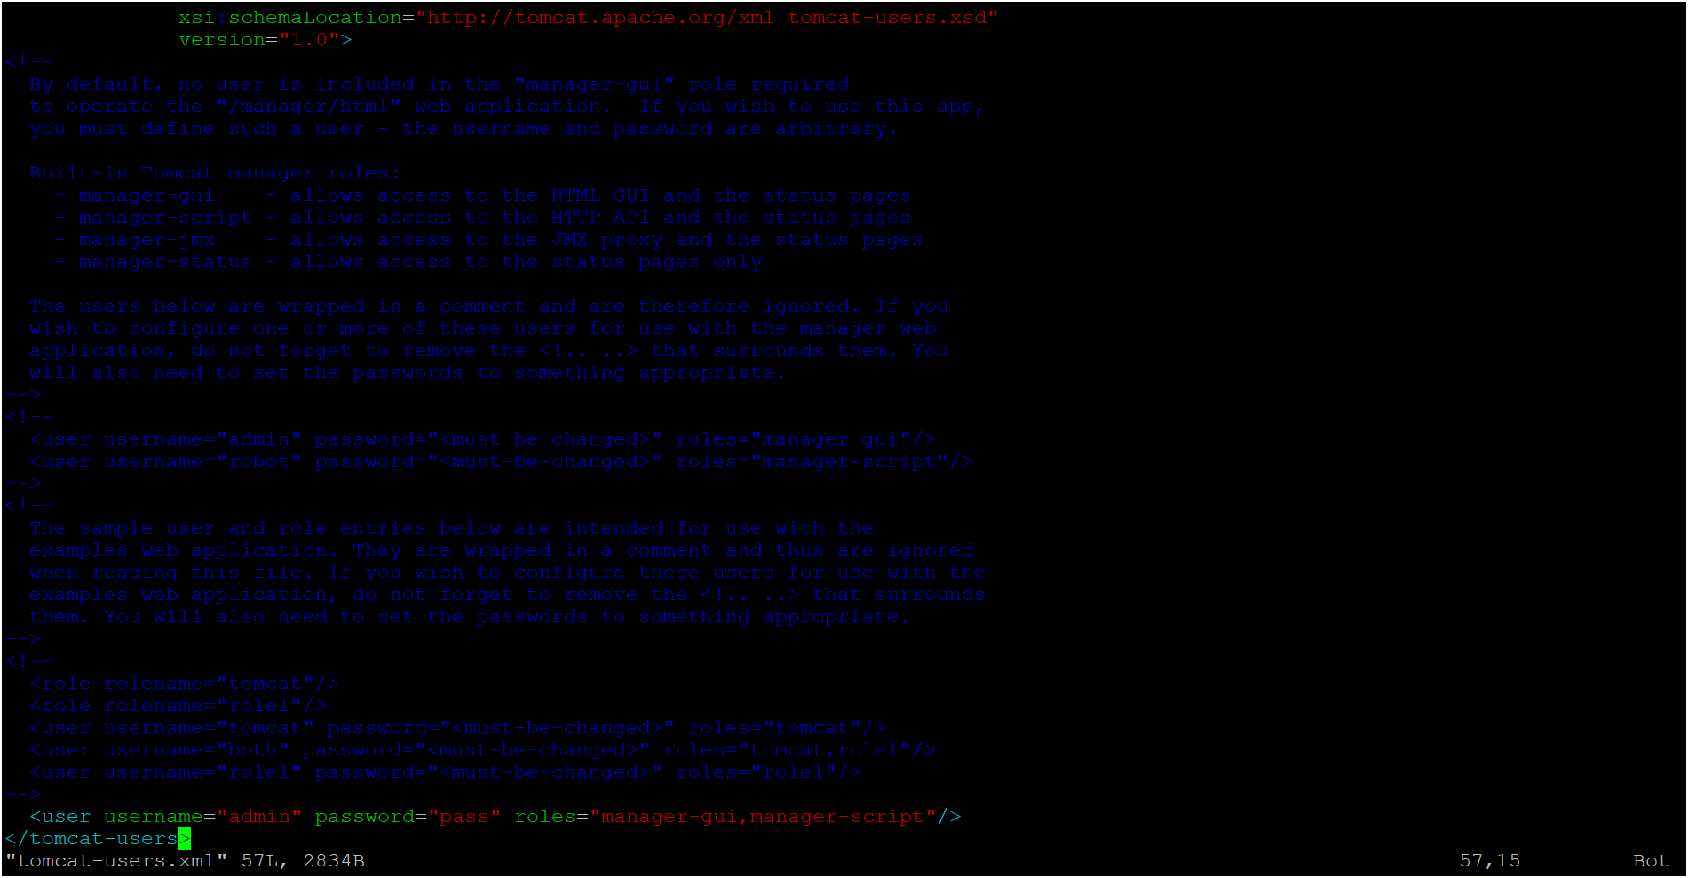
Now you can verify if your service is running properly or not by running your public ip address with port 8080 which is default port for Tomcat in url. You should see the Tomcat welcome page if everything is set up correctly.
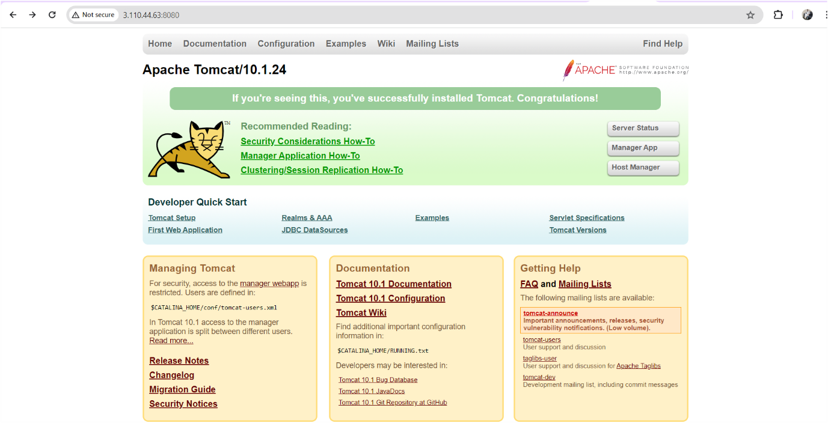
To login to tomcat server click on Manage App after provide credentials

Now configure tomcat server in Jenkins go to manage Jenkinsgo to credentials as shown below image
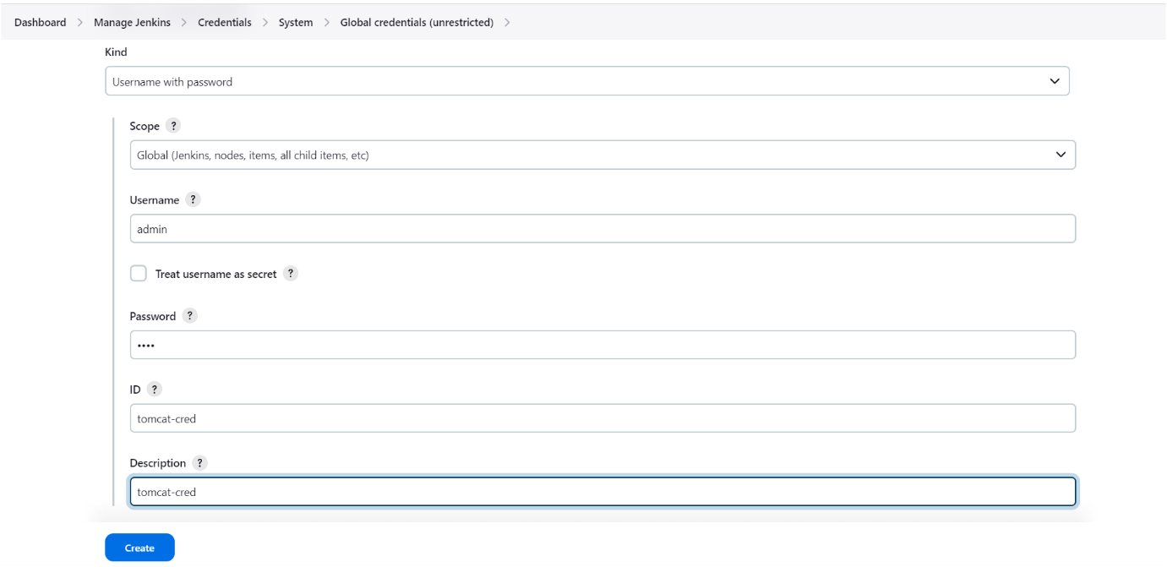
Click on create ️
Let’s create a pipeline
Firstly, we need to create a job or item by clicking on “new item” as shown below image
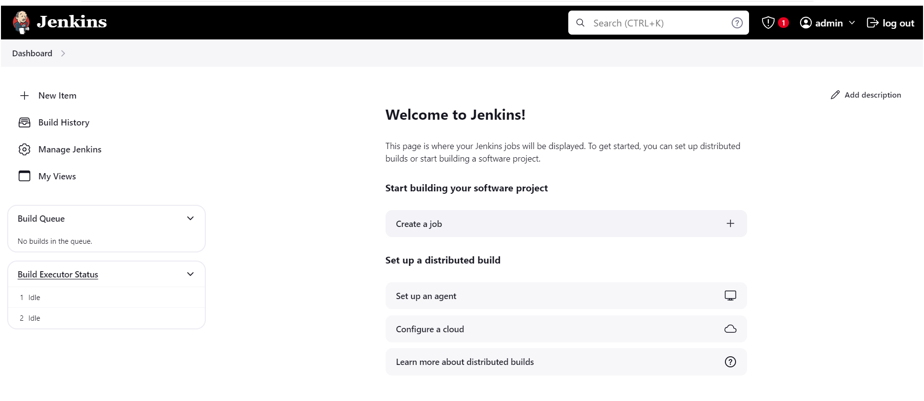

Next, we need to select pipeline type as shown below iamge.
Give nameselect “pipeline”click on “ok”
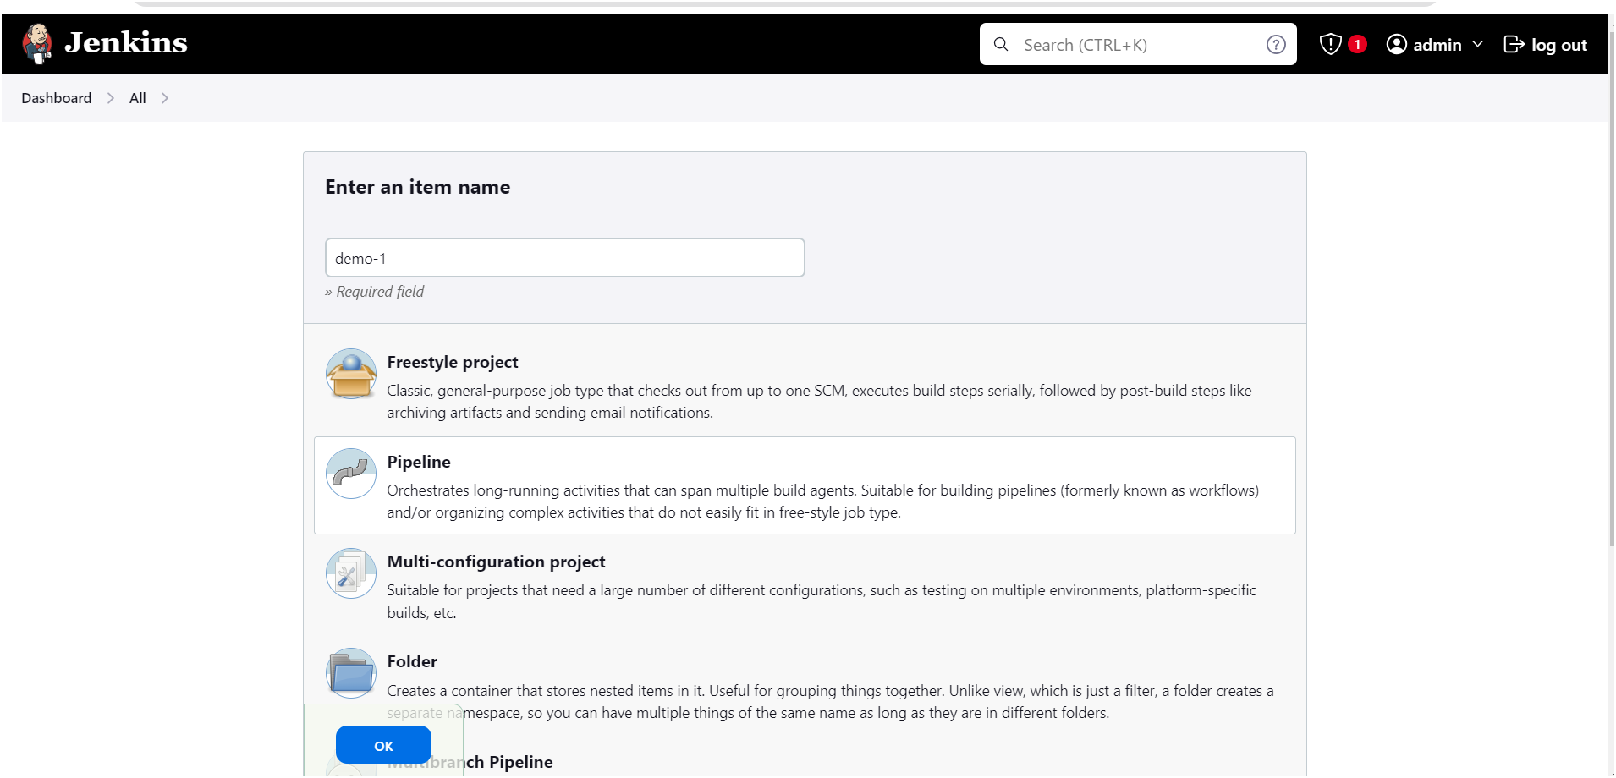
After page will appear as shown below
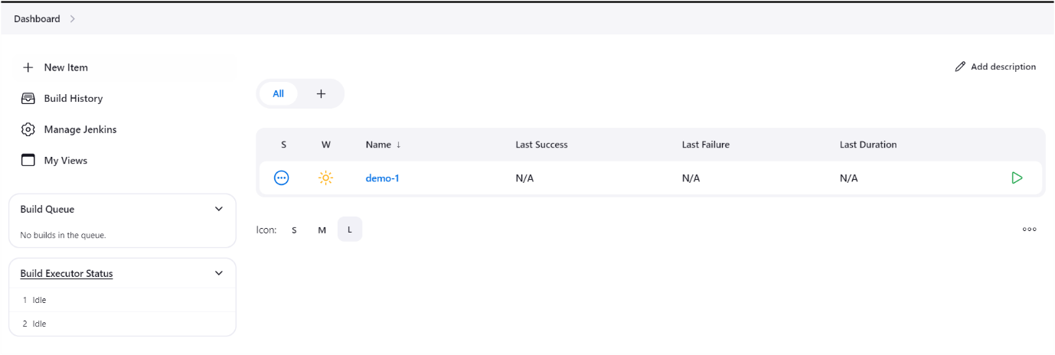
Next click on project name “demo-1”

Let’s start to write declarative pipeline script
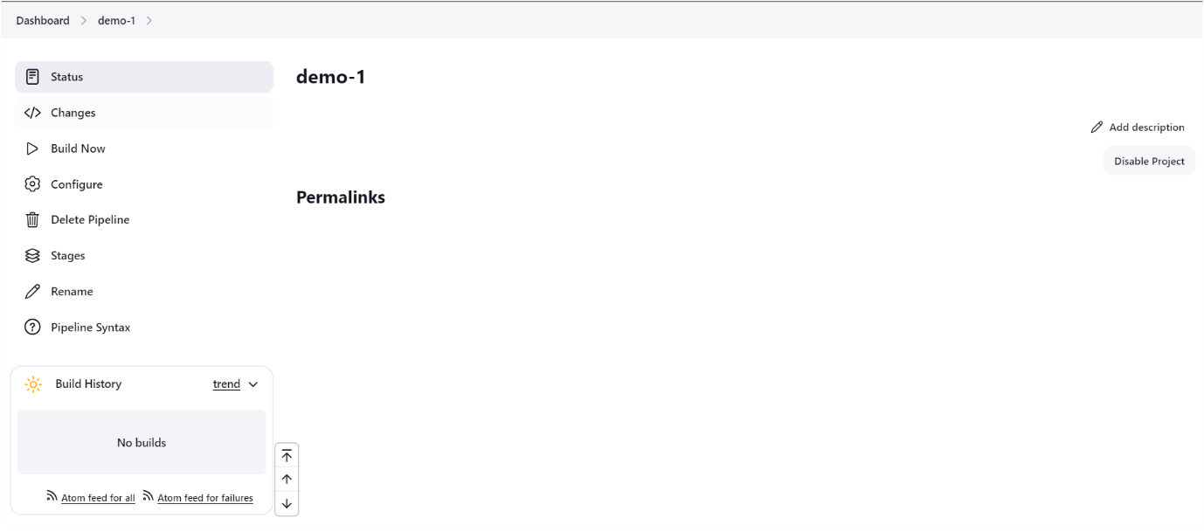
Click on configure ️
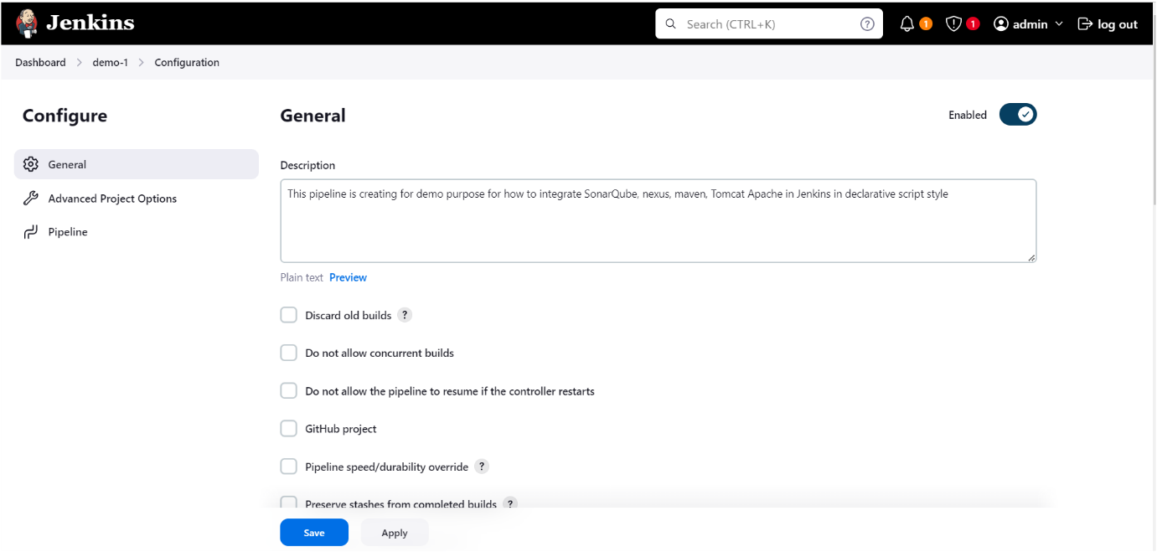
Click on pipeline ️after below page visible
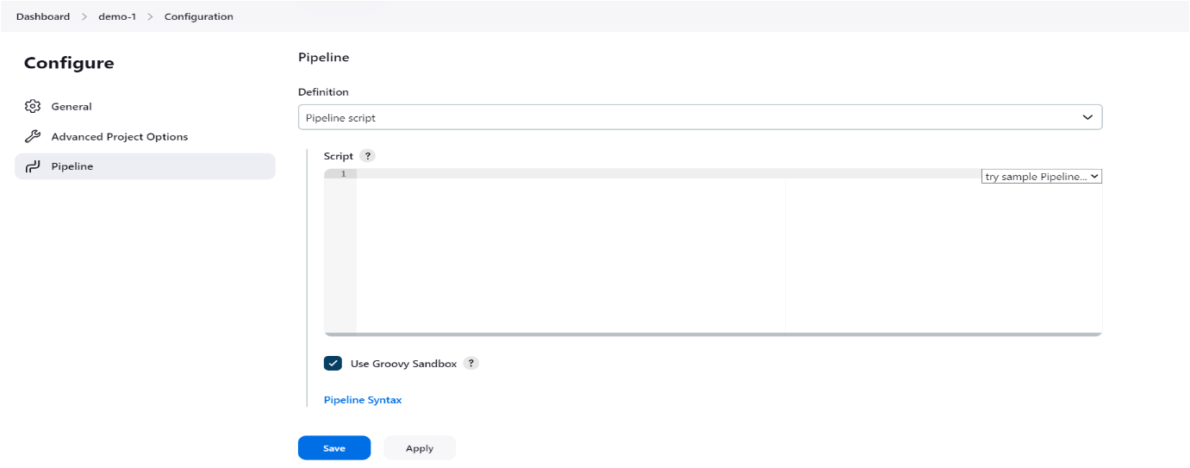
After below page visible
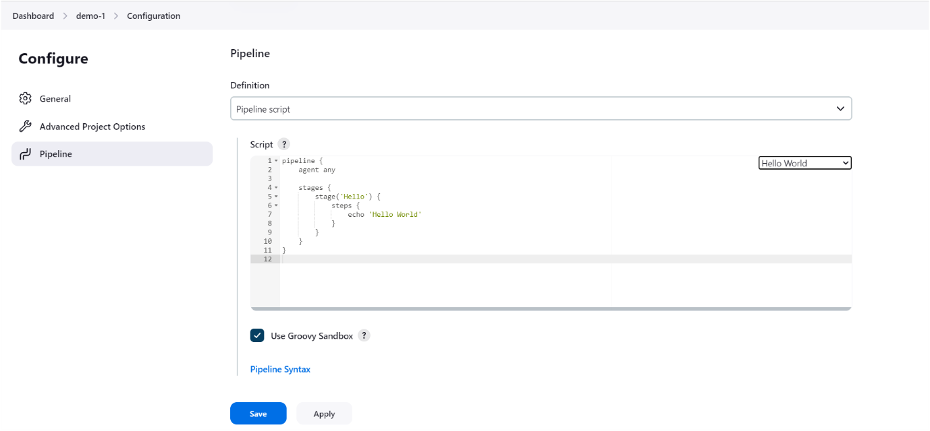
We can write pipeline script by using pipeline syntax after clicking on pipeline sysntax below page will visible
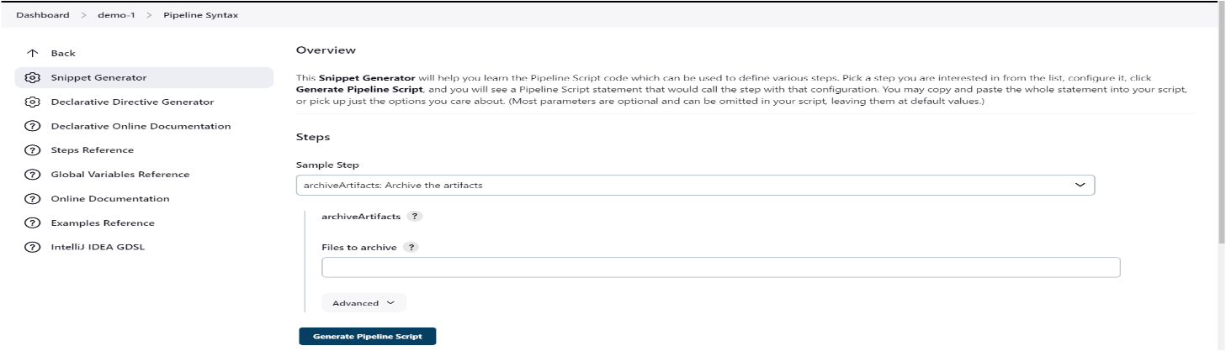
- Generate Git checkout script using pipeline syntax , provide your repository url in Repository URL
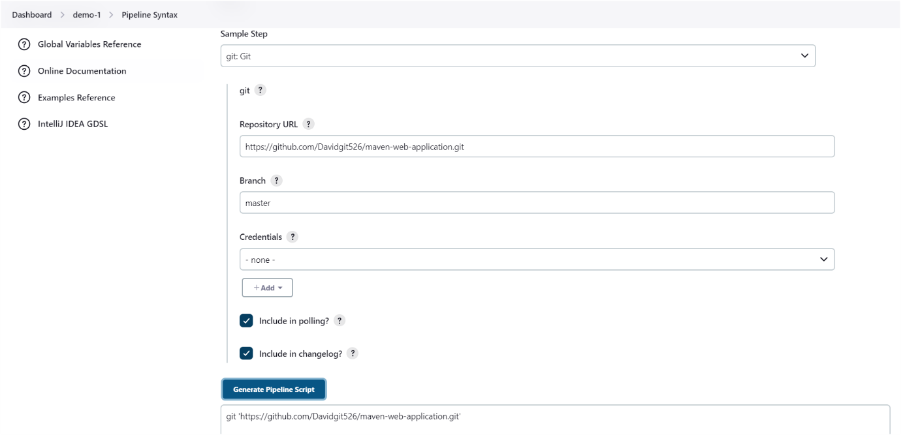
Git checkout script
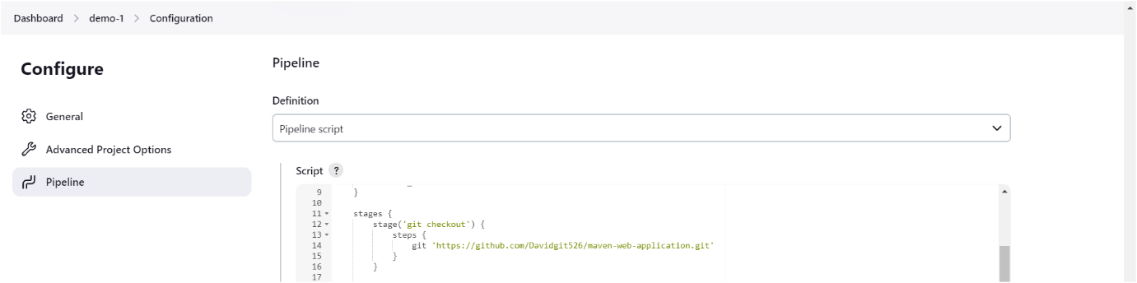
Maven script we need to write manually

Nexus script generate by using pipeline syntax
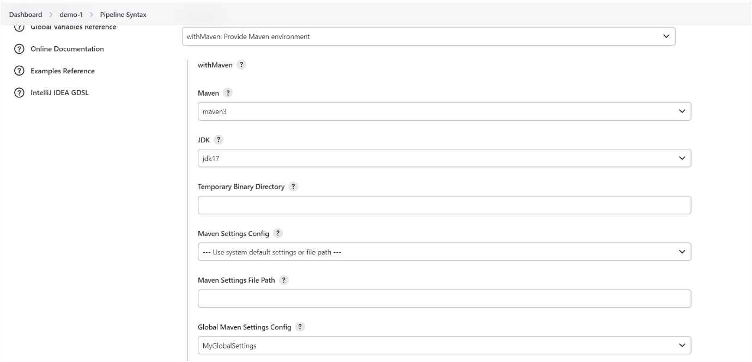
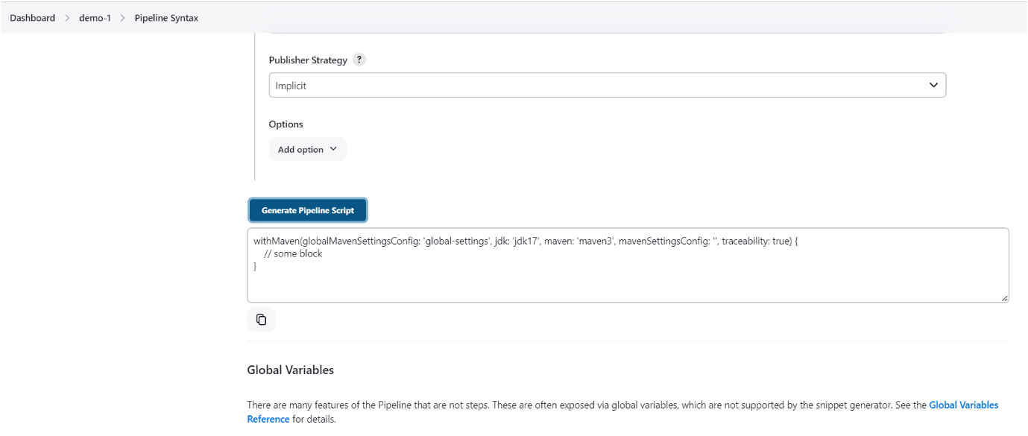

Nexus script

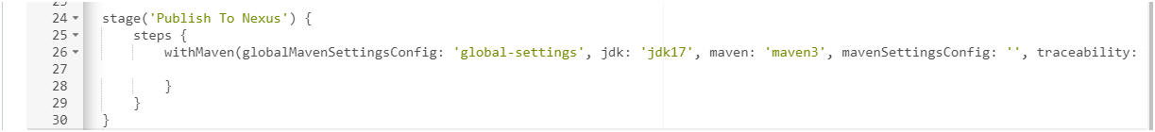

SonarQube script generate
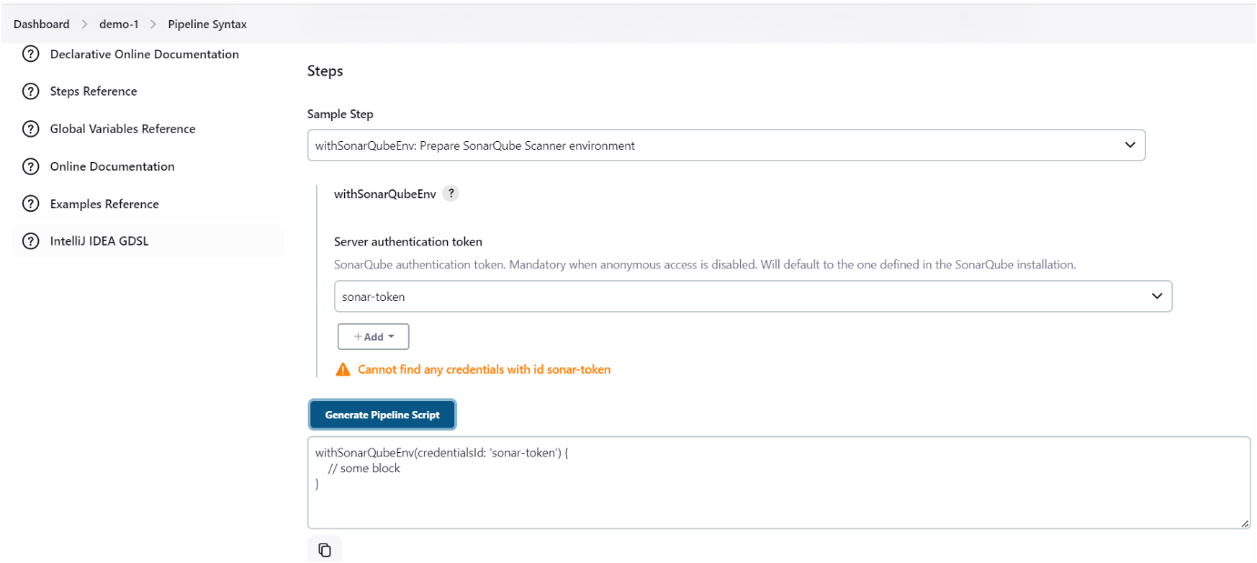
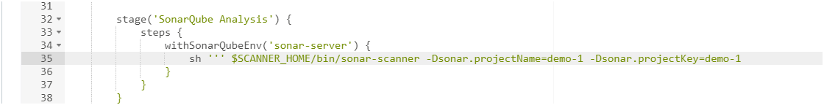

Now we have to generate ssh-key on our Jenkins server for authenticating our Tomcat Apache server follow the below steps
On Jenkins server:
Generate and verify SSH keys on Jenkins server:
ssh-keygen -t rsa

(Press Enter to accept the default file location and leave the passphrase empty.)

cat ~/.ssh/id_rsa.pub

(copy the public and need to paste it on remote server inside authorized keys file)

On remote server: (Tomcat server)
mkdir -p ~/.ssh
chmod 700 ~/.ssh
nano ~/.ssh/authorized_keys

“Ensure the public key is correctly pasted in one line. Save and exit.”
chmod 600 ~/.ssh/authorized_keys

Check SSHD Configuration
Ensure the SSH daemon configuration on the remote server is correct.
On the remote server:
sudo nano /etc/ssh/sshd_config
Ensure the following settings are enabled:(If not remove # symbole)
PubkeyAuthentication yes
AuthorizedKeysFile .ssh/authorized_keys
Save and exit.
Restart SSH Service:
sudo systemctl restart ssh

Test connection with verbose mode:(On Jenkins server)
ssh -vvv -i ~/.ssh/id_rsa user@13.234.87.245

(user-username, remote server ip address)

Now you can check are you able access your tomcat server from Jenkins , if are you able to access then come out of it.

Now need to install ssh agent plugin

Go to Dashboardgo to manage plugins available plugins select ssh agent plugin

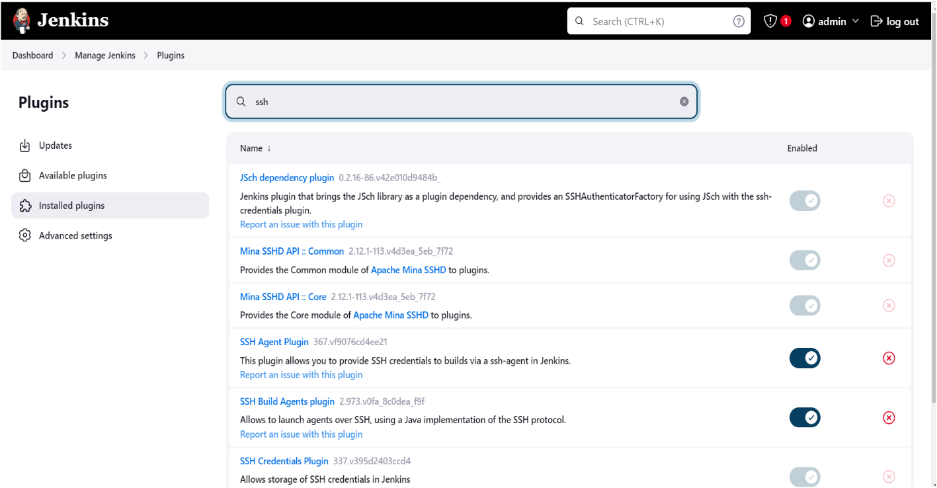

Now configure ssh-key (pvt key) in Jenkins server in credentials section as follow below image

Now copy your private key as shown below

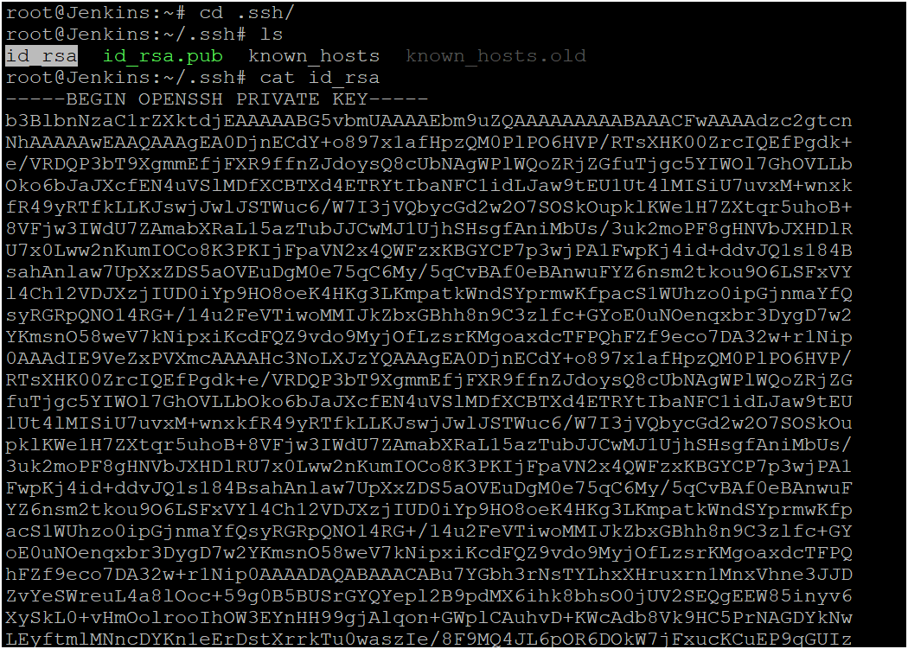
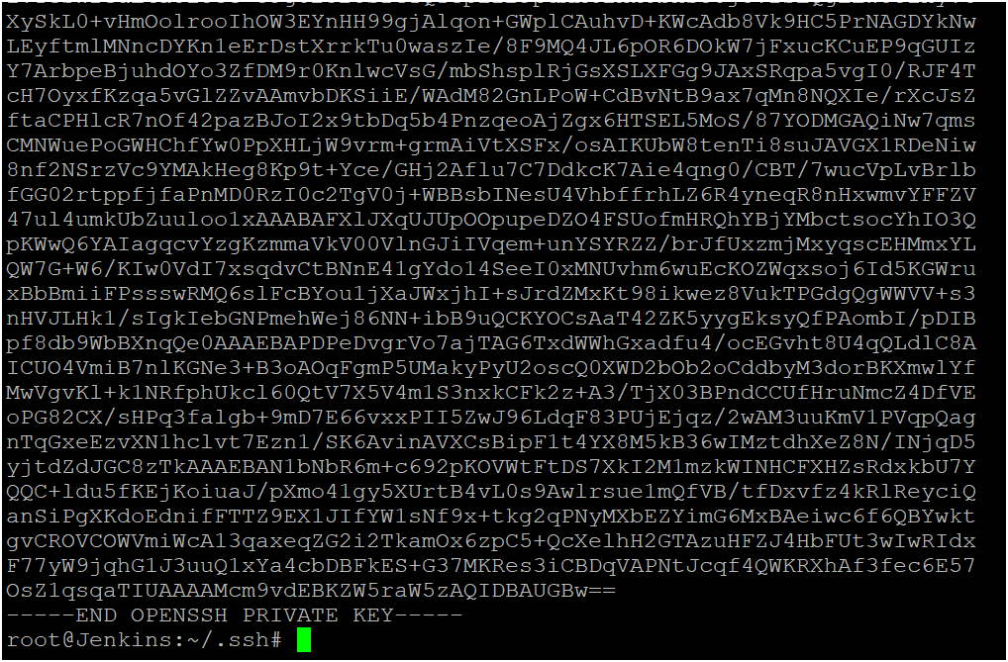

Example of private

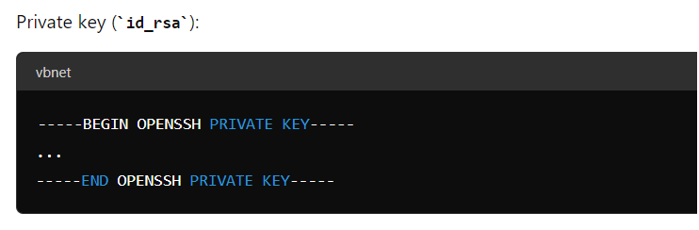

Go to manage plugins go to credentials and configure private key of ssh here

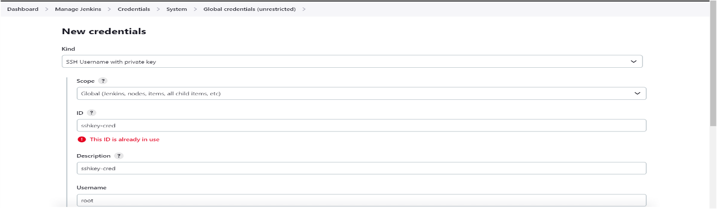
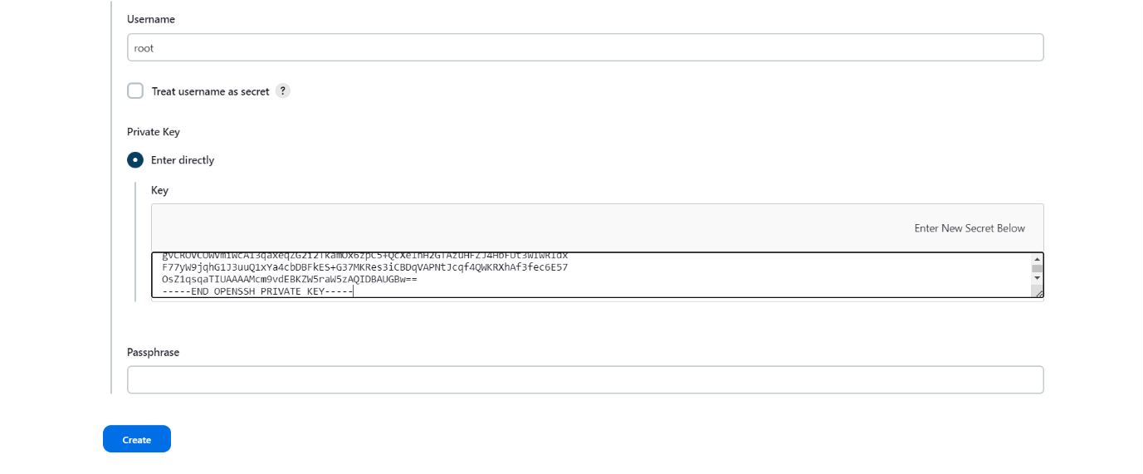
Tomcat ssh-key script generate
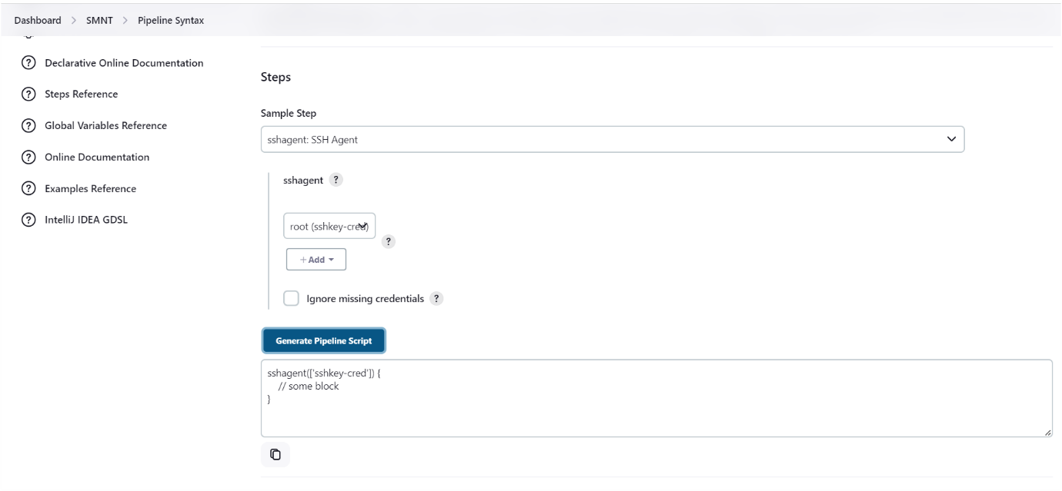

Now we can run entire pipeline script

pipeline {
agent any
tools {
jdk 'jdk17'
maven 'maven3'
}
environment {
SCANNER_HOME = tool 'sonar-scanner'
}

stages {
stage ('git checkout') {
steps {
git branch: 'main', url: 'https://github.com/Davidgit526/Petclinic.git'
}
}

stage('Build') {
steps {
sh 'mvn clean package'
}
}

stage ('Publish To Nexus') {
steps {
withMaven(globalMavenSettingsConfig: 'my-global-settings', jdk: 'jdk17', maven: 'maven3', mavenSettingsConfig: '', traceability: true) {
sh ‘mvn deploy’
}
}
}

stage('SonarQube Analysis') {
steps {
withSonarQubeEnv('sonar-server') {
sh ''' $SCANNER_HOME/bin/sonar-scanner -Dsonar.projectKey=demo-1 -Dsonar.projectName=demo-1 '''
}
}
}
stage('Deploy to tomcat') {
steps {
sshagent(['sshkey-cred']) {
sh 'scp -o StrictHostKeyChecking=no target/petclinic.war root@172.31.38.31:/opt/tomcat/apache-tomcat-10.1.24/webapps'
}
}
}
}
}

Now we can see pipeline status
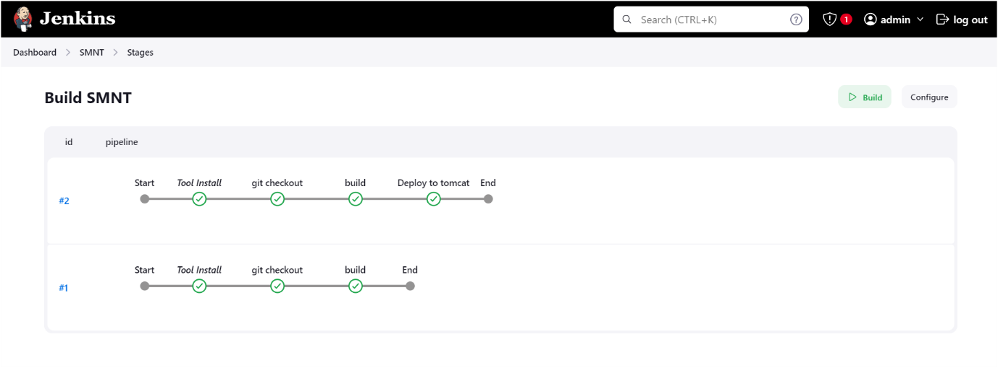
Now we can see the application deployed into the tomcat server

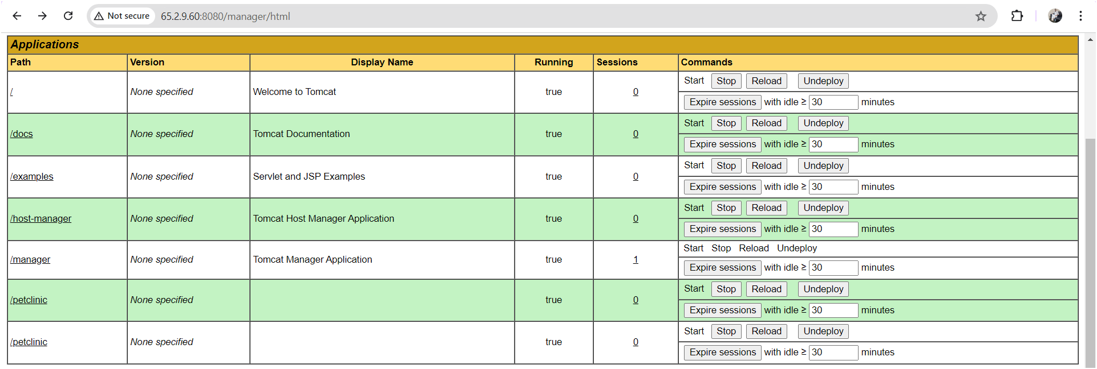

This is for how to integrate SonarQube, maven, nexus and tomcat server in declarative script.

THE END

